Video Conferencing Endpoint
User Manual
V1.0.0

Foreword

General
This document describes the installation and connection of the video conference endpoint.
Safety Instructions
The following symbols may appear in this document and their meanings are as follows:
Symbol | Description
Danger | Indicate a high potential hazard which, if not avoided, will result in death or serious injury.
Warning | Indicate a medium or low potential hazard which, if not avoided, could result in slight or moderate injury.
Caution | Indicate a potential risk which, if not avoided, could result in property damage, data loss, lower performance, or unpredictable result.
Tips | Provide methods to help you solve a problem or save your time.
Notes | Provide additional information as the emphasis and supplement to the text.
Revision History
Version | Revision Content | Release Date
V1.0.0 | New | May 2022

Important Safeguards and Warnings

The following section describes how to use this product correctly and how to prevent dangers and property loss when using it. Before using this product, read this Guide carefully and comply with it strictly. Keep this Guide properly after reading.
Caution
- Modify the default password in time after the Device is armed, to avoid being stolen.
- Do not place or install the Device in a place exposed to sunlight or near the heat source.
- Keep the Device away from dampness, dust or soot.
- Keep the Device installed horizontally in a stable place to prevent it from falling.
- Do not drip or splash liquid onto the Device. Make sure that the Device does not bear any objects filled with liquid to prevent liquid from flowing into the Device.
- Install the Device in a well-ventilated place, and do not block the ventilation of the Device.
- Use the Device only within the rated input and output range.
- Do not dismantle the Device without permission.
Warning
- Use wires (power cables) recommended for the region where the device is used within the specified range of specifications.
- The power supply shall meet the SELV requirement. Use the power supply that conforms to Limited Power Source, according to IEC60950-1.
- Make sure easy operation of disconnection devices such as power plug or appliance coupler.
Disclaimer
- The instruction is for reference only, and the actual product shall prevail.
- The instruction and program are subjected to change without notice.
- We are not liable for any loss caused by operations that do not comply with instructions.
- There still might be deviations in technical data, functions and operation descriptions, or errors in print. If there is any doubt or dispute, please refer to our final explanation.
- All other company names and trademarks mentioned herein are the properties of their respective owners.
Table of Contents

Foreword I
Important Safeguards and Warnings II
1 Product Introduction 4
1.1 Overview 4
1.2 Features 4
1.3 Structure 4
1.3.1 Front Panel 4
1.3.2 Rear Panel 5
1.4 Remote Control 7
2 Networking 8
3 Product List 9
4 Initial Settings 10
4.1 Camera Connection 10
4.2 Power on 10
4.3 Power off 11
4.4 Main Page 11
4.5 Local Camera Adjustment 12
4.5.1 Local Camera Preview 12
4.5.2 Preview Selection 12
4.5.3 Edit Preset Positions 14
4.5.4 Call Preset Positions 15
4.6 Conference Setup 16
4.6.1 Network Configuration 17
4.6.2 Server Configuration 17
4.6.3 Log In 19
5 Meeting 20
5.1 Meeting Basics 20
5.1.1 Start Meeting 21
5.1.2 Join Meeting 22
5.1.3 Reserve Meeting 22
5.2 Meeting Controls 25
5.2.1 Host Endpoint 25
5.2.2 Non-host Endpoint 27
6 System Settings 29
6.1 Common Settings 29
6.2 Video Settings 30
6.3 Audio Settings 31
6.4 Network Settings 31
6.5 Other Settings 32
Appendix1 Technical Specification 33

Product Introduction

Overview
This product is a full HD and split-type video conferencing endpoint with rich audio and video connectors, multi-view transmission, and Wi-Fi interconnection functions, providing dual-stream 1080P60fps ultra-high-definition picture and OPUS broadband voice, bringing a face-to-face communication experience. It is ideal for the integrated construction of medium or large-scale video conferences for industrial customers.

Features
- Support H265 video codec and 1080P60fps dual-stream.
- Support OPUS audio codec and 49KHz sampling rate.
- Support USB omnidirectional microphone access.
- Super network anti-packet loss capacity, ensuring good audio and video conferencing
experience under 30% packet loss.
- Rich audio and video connectors, support HDMI, VGA, 3G-SDI, and other connector types.
- Support infrared remote control, mouse, keyboard, and other peripheral control.

Structure

Front Panel
Figure 1-1 Front Panel of Video Conferencing Endpoint
Table 1-1 Components of Front Panel
No. | Component | Description
1 | OLED Display | Show IP address, endpoint number, upgrade, sleep and error status
2 | Alarm Indicator | Indicate an error state
3 | Status Indicator | Indicate a running or sleep state

Rear Panel
Figure 1-2 Rear Panel of Video Conferencing Endpoint
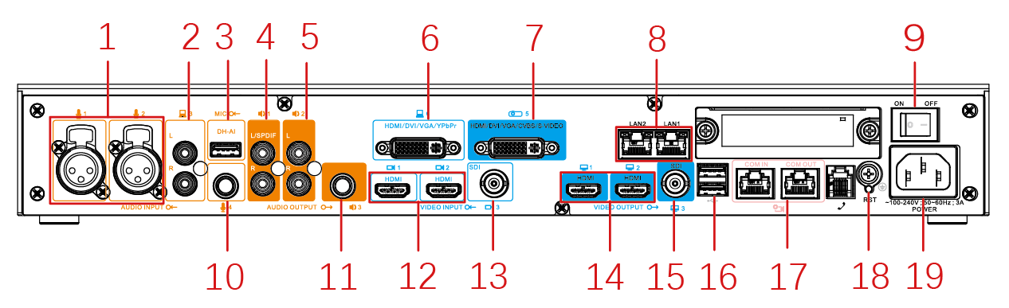
Table 1-2 Connectors of Rear Panel
No. | Connector |  | Description
1 | Audio Input Connector | Canon Connector, also known as XLR Connector. | Connect to the microphone by XLR connector to capture and input the sound of the video conference.
2 |  | RCA Connector, also known as Lotus Connector, its L and R represent the left and right audio channels. | Connect to sound input sources such as computers and mobile phones to receive sound.
3 |  | Microphone Array Connector | Connect to the microphone array
10 |  | 6.35mm Audio Input Connector | Connect to the external microphone
4 | Audio Output Connector | RCA Connector with SPDIF Output  - SPDIF can be used as the left audio channel or as the SPDIF audio output connector.  - R represents the right audio channel. | As the Line1, it can connect to external speakers, or as the reserved audio output, it can be used as SPDIF audio output at the same time.
5 |  | RCA Connector, also known as Lotus Connector, its L and R represent the left and right audio channels. | As the Line2, it can connect to external speakers to output the sound of the video conference.
11 |  | 6.35mm Audio Output Connector | Used to connect to external speakers.
6 | Video Input Connector | Multi-functional Input Connector supports HDMI/DVI/VGA/YPbPr high-definition video inputs. | As the input way 4, it is used to input the sub video stream containing images and videos from the device screen for the projection at the conference.
12 |  | HDMI High-definition Video Input Connector supports up to 1080P60fps resolution. | As the input way 1 and 2, both HDMI1 and HDMI2 can be used to input the main video stream from cameras for constructing the main view.
13 |  | SDI Input Connector supports up to 1080P60fps resolution. | As the input way 3, it is used to input the video stream of the auxiliary camera.
7 | Video Output Connector | Multi-functional Output Connector supports HDMI/DVI/VGA for the HD video output and CVBS/S-Video for the SD video output. | As the output way 4, it is used to output the sub video stream containing images and videos from the remote video conferencing endpoints for projection at the conference for example.
14 |  | HDMI High-definition Video Output Connector supports up to 1080P60fps resolution. | As the output way 1 and 2, HDMI1 outputs the local view by default and HDMI2 can be used for presentation or sharing purposes.
15 |  | SDI Output Connector supports up to 1080P60fps resolution. | As the output way 3, it is used to output the video stream of the auxiliary camera.
8 | Other Connector | Ethernet Connector supports 10M/100M/1000M full-duplex mode, IP network transparent transmission, and dual network interface backup. | - LAN1 is main network interface  - LAN2 is the transparent transmission network interface and backup network interface
14 |  | USB Connector supports 2 ways of connection. | For external USB devices, such as keyboard, mouse, USB drive or data card and other devices.
17 |  | COM dual-mode serial communication connector | This connector can be used to connect the camera control line and can also be used for diagnosis and maintenance.
18 |  | Reset Button | During the endpoint running, hold the button for 10 seconds to restore factory settings.
9 |  | Power Switch | Used to turn the endpoint on or off.
19 |  | Power Input Connector，AC 100V～240V，50Hz/60Hz。 | Used to connect the power supply to power the endpoint.

Remote Control
Figure 1-3 Remote Control Table 1-3 Description
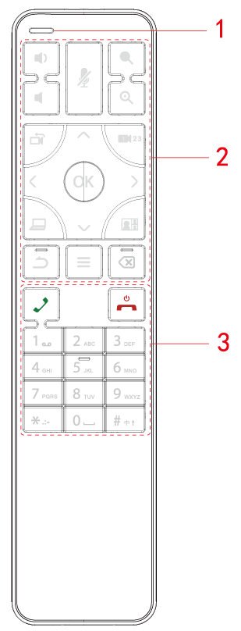 | No. Icon Description  1 Signal Indicator  2 Volume Button  Microphone Button: Mute or unmute the microphone at the conference.  Camera Focus Button: Adjust the focus of the camera.  Same as Back Button for oversea version.  Camera Selection Button: Select a camera if multiple cameras are connected to the endpoint.  Sub Video Stream Button: Send the sub video stream from a device connected to the endpoint at the conference.  Layout Button: Change the layout at the conference.  - Select Menu or Camera Direction  - Up, Down, Left, Right Direction  OK Button: Confirm an action.  Back Button: Go back to a previous page or an action.  Menu Button: Display the camera menu or extended features.  Backspace/ Delete Button: Delete an input such as a number or a character.  3 Dial Button: Enter the dial page or dial in.  End Button: End a conference, shut down or sleep the endpoint.  Number Button: Input numbers, Chinese or English characters.

Networking

For the networking of the video conferencing endpoint, see Figure 2-1.
Figure 2-1 Networking Diagram

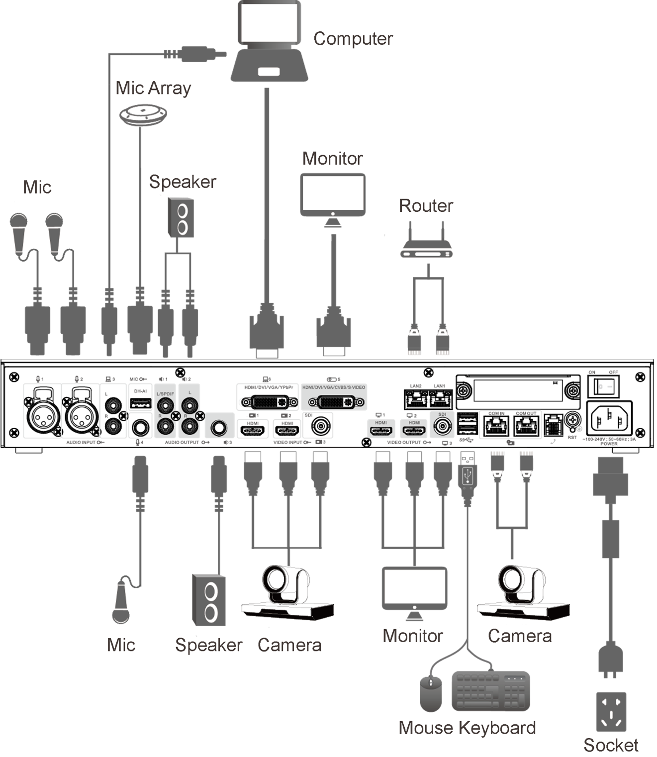

Product List

Before connecting the device, check the items in the package according to Table 3-1
Table 3-1 Product List
No. | Name | Qty | Description
1 | Endpoint | 1 | Video conferencing endpoint
2 | Remote Control | 1 | For the remote control of endpoint
3 | Audio Socket-Adapter (audio 6.5mm male to 6.35mm female) | 2 | For the conversion of audio signal
4 | Power Cable | 1 | Connect the endpoint to the power supply.
5 | Accessory Cable-(audio and video cable, DVI-I to VGA and HDMI)-black-300mm | 2 | Audio and Video Cable
6 | Accessory Cable - (video cable, DVI-I to RCA and SVIDEO) black - 300mm | 1 | Video Cable
7 | Accessory Cable-(audio cable, DVI-I to 3 RCA, red, green and blue) black-300mm | 1 | Audio Cable
8 | Standard External Cable-(serial cable DB9F to USB3.0 male)-black-2000mm | 1 | Debug Cable
9 | Hook | 2 | For the installation of endpoint
10 | M3×10 Cross Recessed Flat Head Machine Screws – Black Zinc Plating | 8
11 | Product Information and QR Code | 1 | Guidance on quick installation, connection and use of the device
12 | Certificate, Warranty Card and Hazardous Material Table | 1 | Product Certificate, Warranty Card, Hazardous Material Table.

Initial Settings

Camera Connection
Figure 4-1 The diagram of Camera Connection
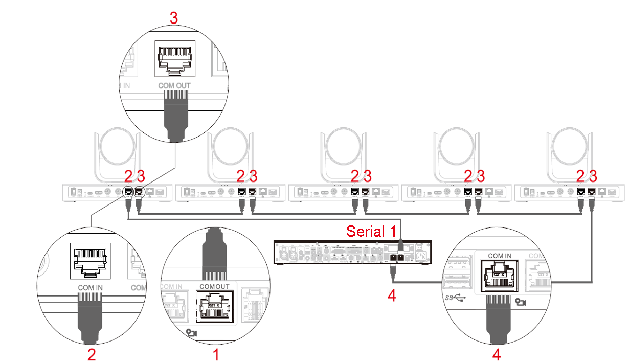
Notes
- The endpoint can connect up to 7 cameras in series, and only supports VISCA protocol cameras.
- Press the Camera Selection Button to select and control each camera. (For example, if Camera 1 is displayed in the upper left corner of the screen, it is being controlled now.)

Power on
Caution
- Make sure that the input voltage of the power supply corresponds to the power supply of the device, and please confirm that the device is properly connected to the power cable before turning on the power switch.
- To protect the device, please connect the device to the power adapter before turning on the power.
- To ensure the smooth operation of the endpoint and external devices (such as cameras) and prolong the service life of the hard disk, it is recommended that you refer to international standards to provide a power input with stable voltage value and little ripple interference. UPS power supply is recommended.
- The endpoint can be operated in three ways: the remote control, keyboard, and mouse. This quick start guide takes the remote control as an example.
Steps to power on the endpoint are the following:
Step1: Connect the endpoint to cameras, microphones, speakers, and monitors.
Step2: Plug in the power supply and turn on the monitor and then press the power button.
Step3: After powering on the endpoint, change the input channel of the monitor to HDMI and the main page of the system will be displayed at this time.

Power off
- Power off by the remote control.
Press the End Button to shut down the endpoint.
- Power off by the Power Switch on the rear of the endpoint.

Main Page
Figure 4-2 Introduction to the main page of the system
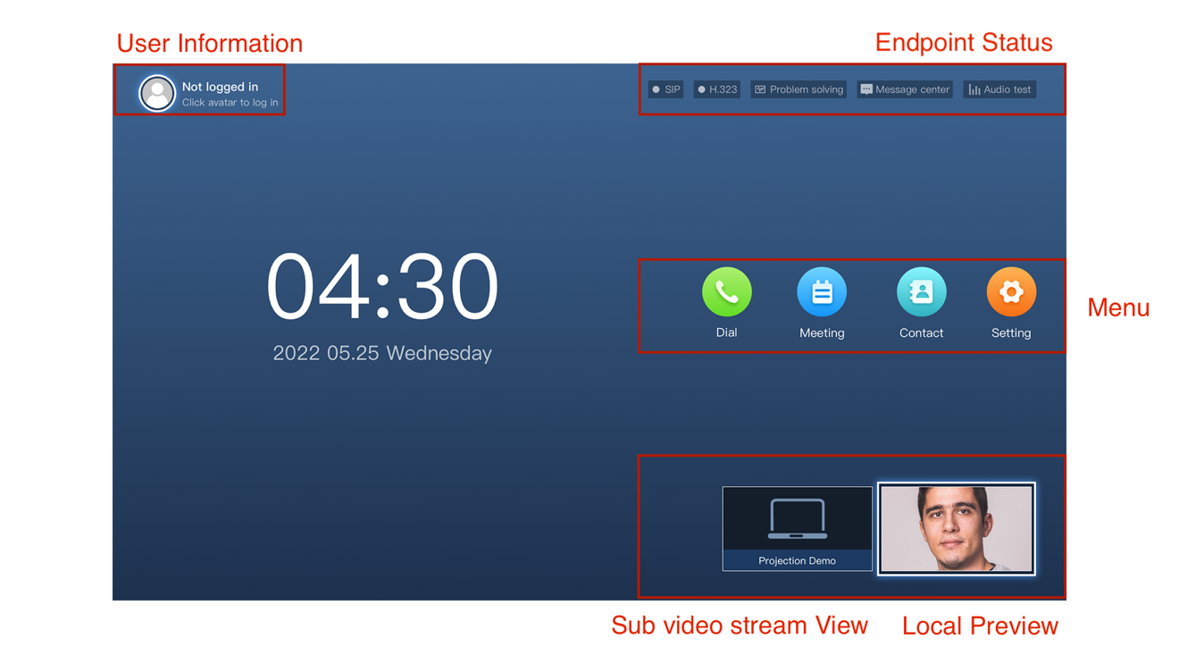

Local Camera Adjustment

Local Camera Preview
Use the local camera preview to adjust the picture of the local camera before the conference.
Step1: Select the “Local Preview”
Step2: Press the button on the remote control to enter the local preview.
Figure 4-3 Local Camera Preview
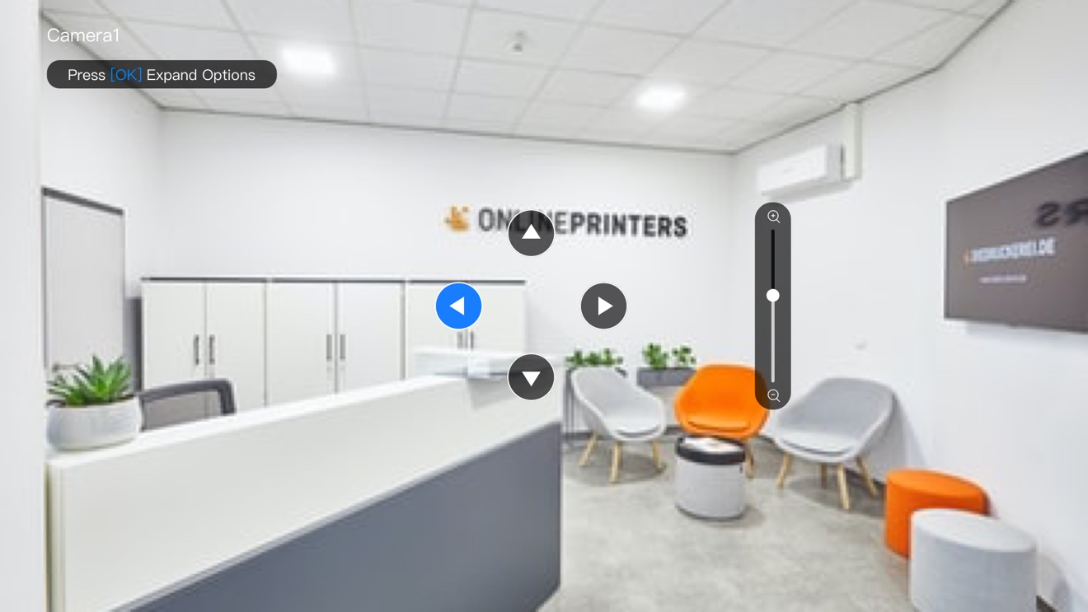
Step3: Set the camera
- Press the button on the remote control to adjust the direction of the camera.
- Press the button on the remote control to zoom in or out.

Preview Selection
The preview selection allows you to select previews from different video input sources before the conference.
Step1: Press the button on the local preview page.
The system will show the function menu, referring to Figure 4-4.

Figure 4-4 Function Menu
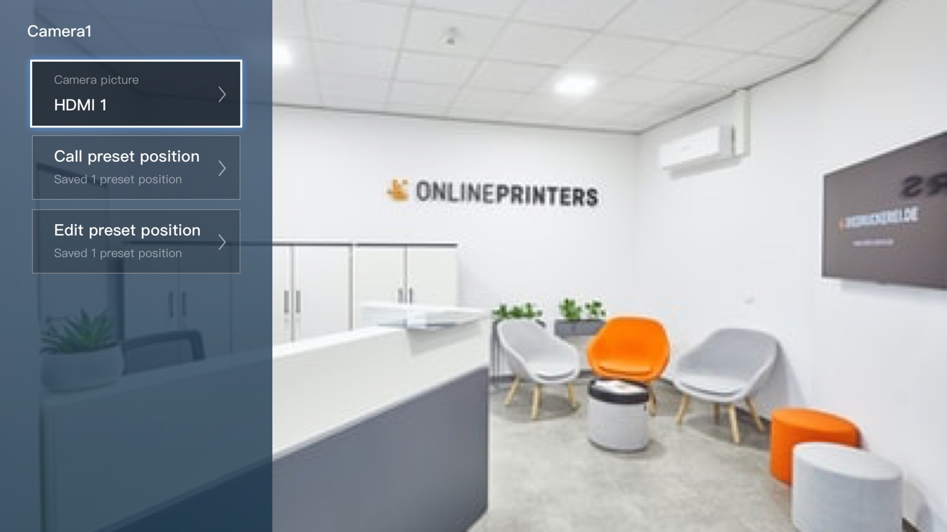
Step2: Select “Current Picture” and press .
Notes
The local picture supports four types of video input including HDMI1, HDMI2, SDI3 and Fusion Screen which combines two types of video stream at most.
Figure 4-5 Local Camera Picture
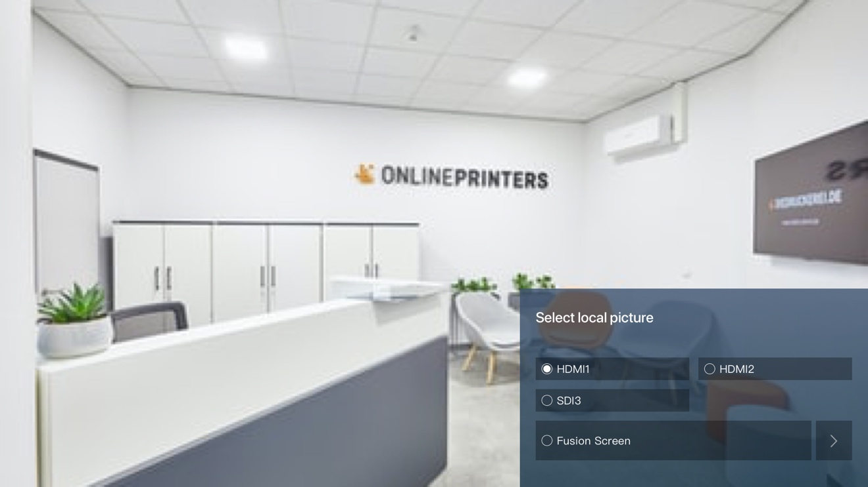

Edit Preset Positions
Editing presets saves the positions of a camera and switch to them anytime.
Notes
Use an ethernet cable to connect cameras in series to the endpoint's COM IN/OUT connectors.
Step1: Press on the local preview page.
The system will show the function menu, referring to Figure 4-6.
Figure 4-6 Function Menu
Step2: Select “Edit Preset Position” in the function menu.
The system will show the “Editing Preset Position” page, referring to Figure 4-7.
Figure 4-7 Edit Preset Position
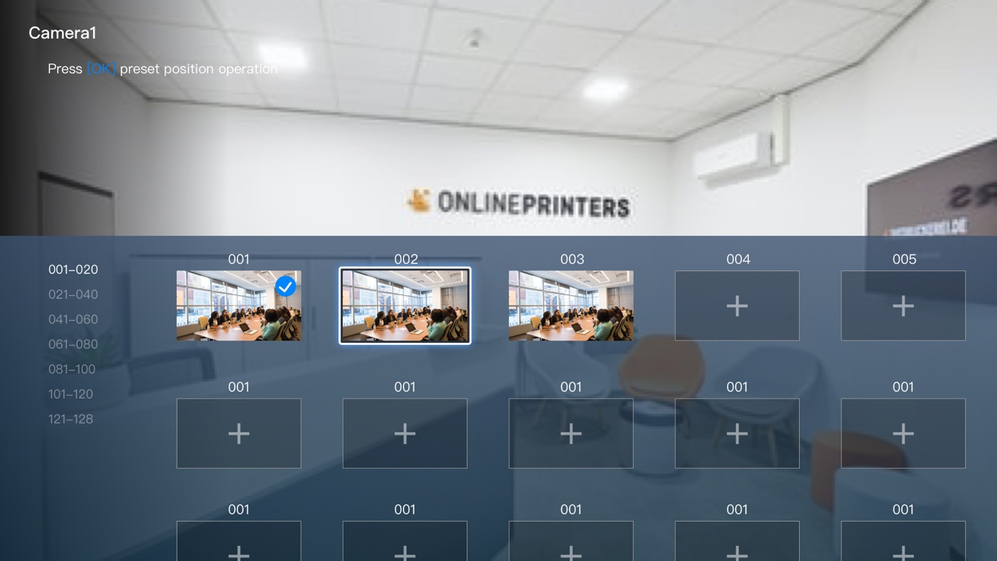
Step3: Press 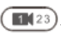 to change cameras and select a preset to adjust the camera position.
Step4: After finishing adjusting the position, press to save the adjustment.

Call Preset Positions
The camera can go back to a preset position after it has been called.
Step1: Press on the local preview page.
The system will show the function menu, referring to Figure 4-8.
Figure 4-8 Function Menu

Step2: Select “Call Preset Position” in the function menu.
The system will show the “Call Preset Position” page, referring to Figure 4-9.

Figure 4-9 Call Preset Position
Step3: Press to switch cameras.
Step4: Select a preset position and press . The camera will quickly go back to the position specified by the preset.

Conference Setup
Please refer to Figure 4-10 to quickly set up the endpoint for the conference.
Figure 4-10 Quick Setup
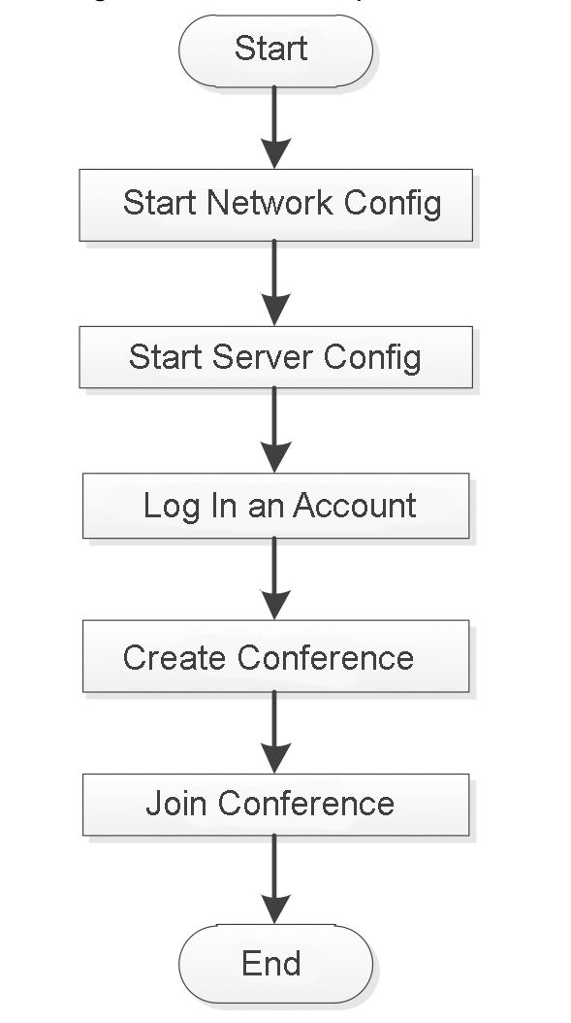

Network Configuration
Step 1: Select “Setting > Network > Wired Network”
The system should display the page, referring to Figure 4-11.
Figure 4-11 Wired Network Setting
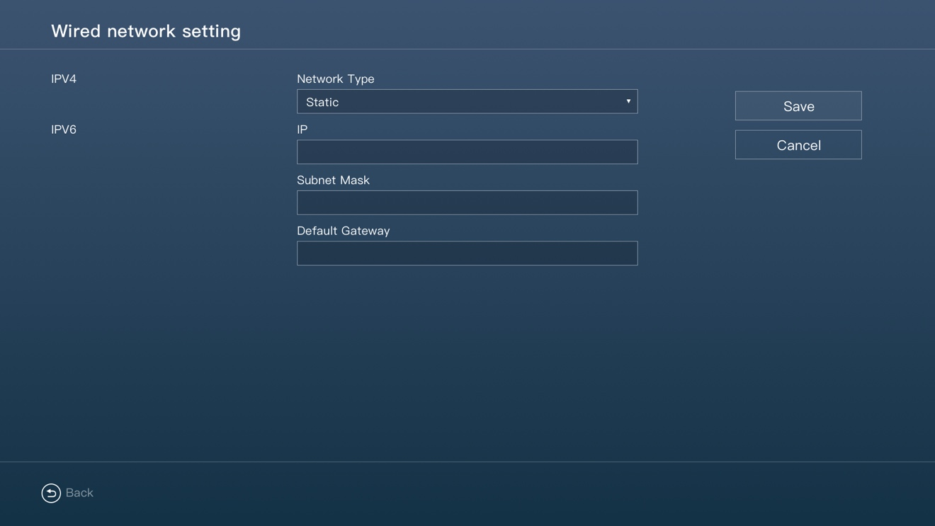
Table 4-1 Parameter Description
Parameter | Description
IP Type | Support IPv4 and IPv6 configuration.
Network Type | - Static  Manually set the IP, subnet mask and default gateway.  - DHCP  Auto search for the IP, subnet mask and default gateway.
Step2: Click the “Save” button to save the configuration.

Server Configuration
Notes
After powering on the endpoint, select the required server type according to the actual situation and complete the server configuration. Otherwise, the endpoint cannot connect to the server and the cloud video conferencing service is inaccessible.
Step1: Select “Setting > Network > Server Setting”
The system will show the “Server Setting” page as Figure 4-12.

Figure 4-12 Server Setting
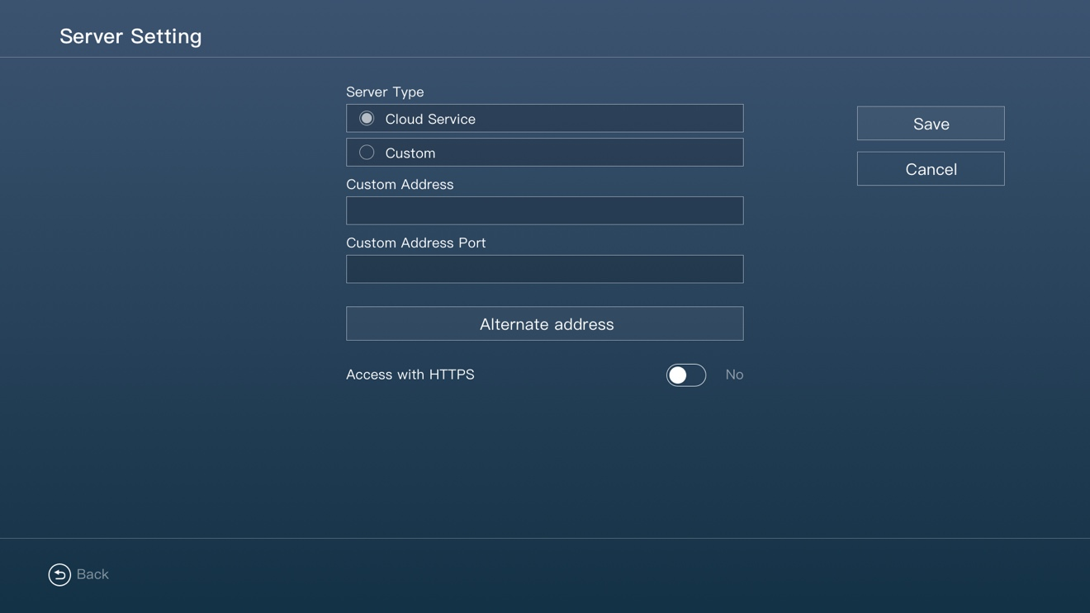
Step2: Select the server type
- Cloud Service: Connect to the cloud platform by default
- Custom: Manually input the server address and port number.
Step3: After the completion, press the “Save” button to save the configuration.
Step4: Go back to the main page and press the “Problem Solving” button to see the network topology, referring to Figure 4-13.
Figure 4-13 Network Topology
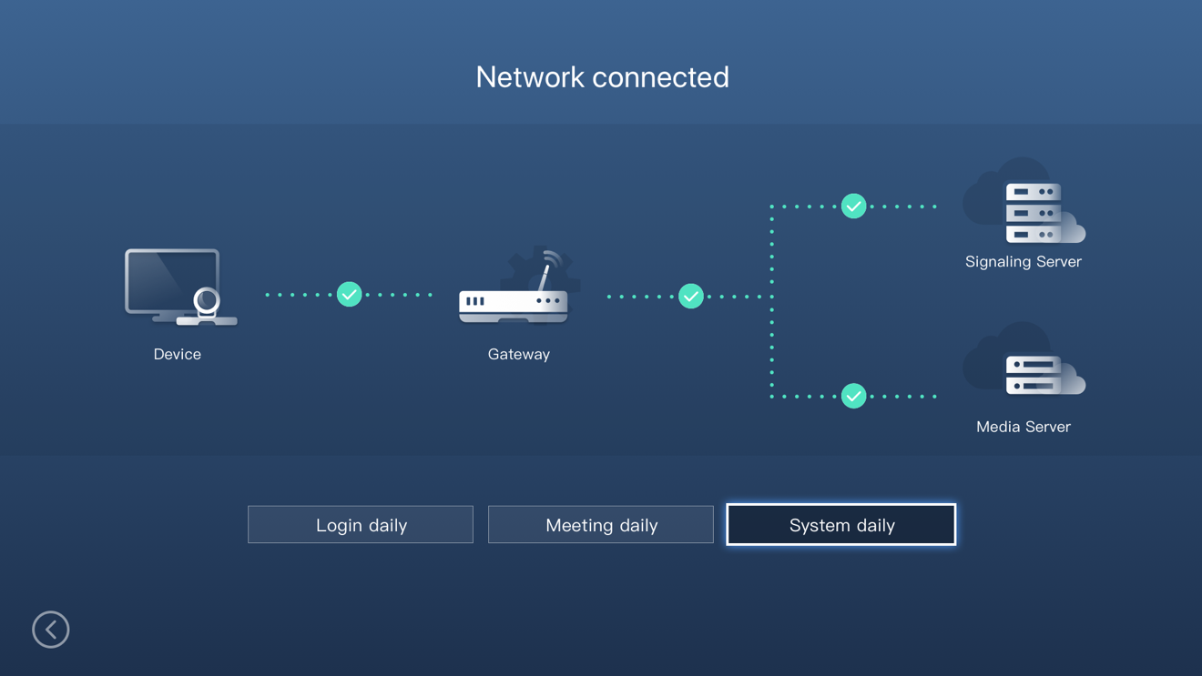

Log In
Step1: Select “Not Logged In” if the endpoint has not been logged in yet and press .
The system will show the “log in Account” dropdown, referring to Figure 4-14.
Figure 4-14 Log In Account
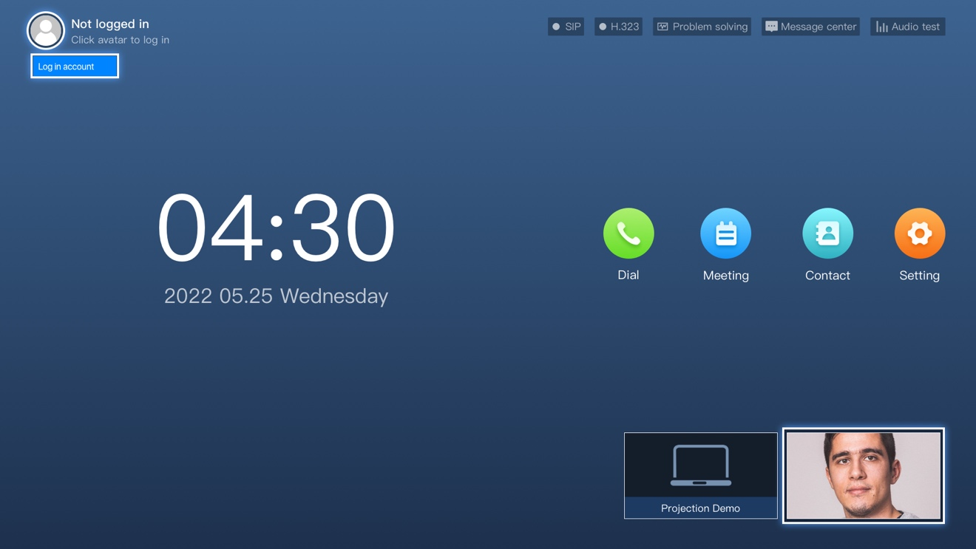
Step2: Press to enter the login page, referring to Figure 4-15.
Figure 4-15 Login Page
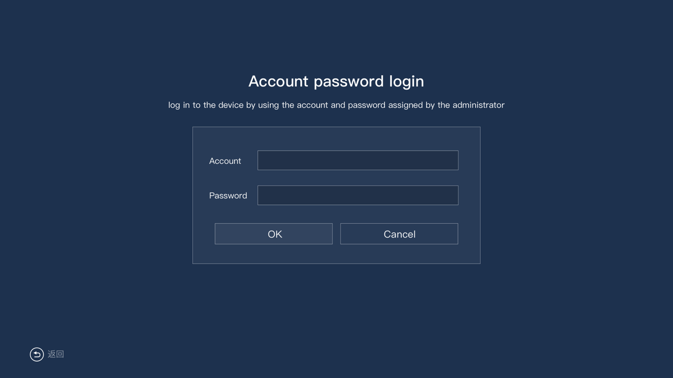
Step3: Input the account and password.
Step4: Press the “OK” button on the page to enable the video conferencing service.

Meeting

Meeting Basics
Press the “Meeting” button on the main page, referring to Figure 5-1.
Figure 5-1 Meeting Button
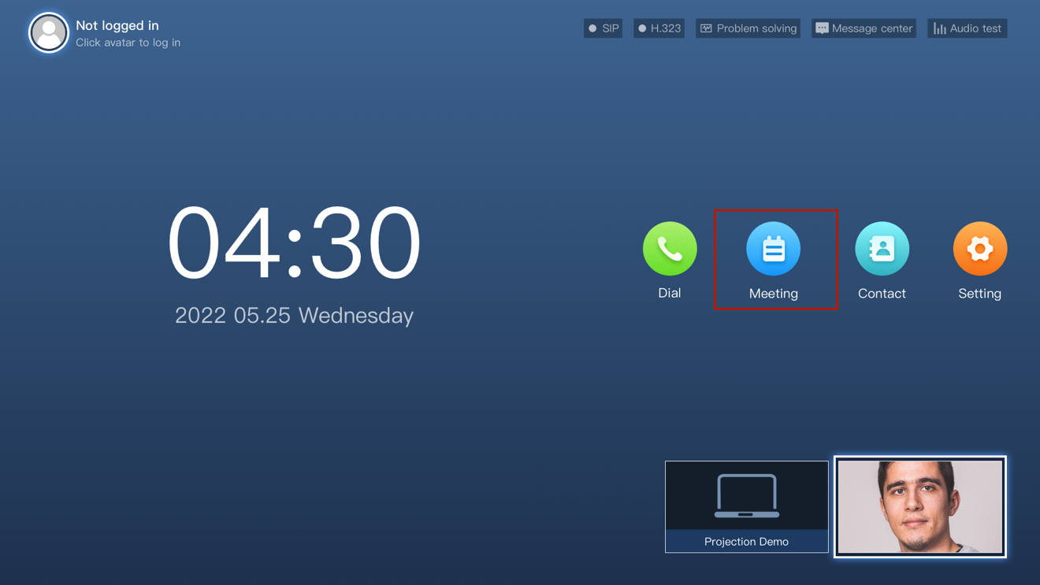
This will head to the meeting center page, as described in Figure 5-2.
Figure 5-2 Meeting Center
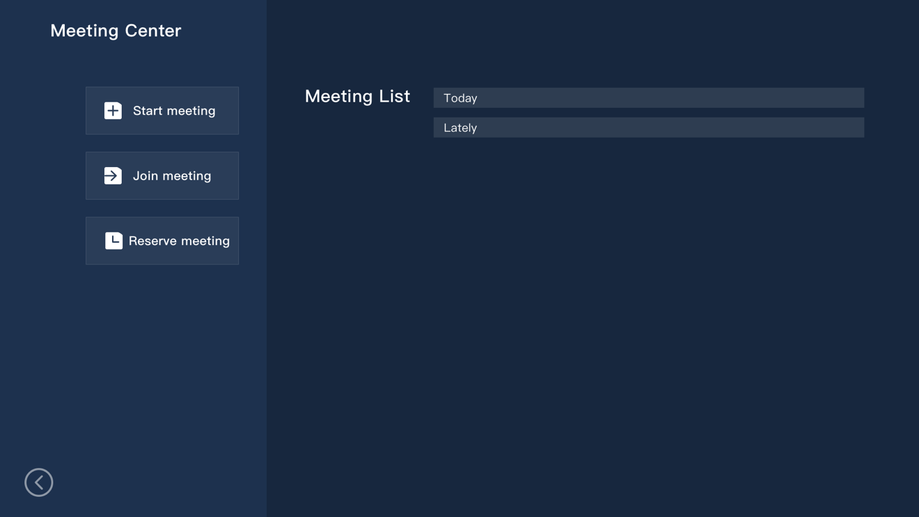

Start Meeting
Starting a meeting means instantly creating a conference.
Step1: Select the “Start Meeting” to enter the start meeting page, referring to Figure 5-3.
Figure 5-3 Start Meeting
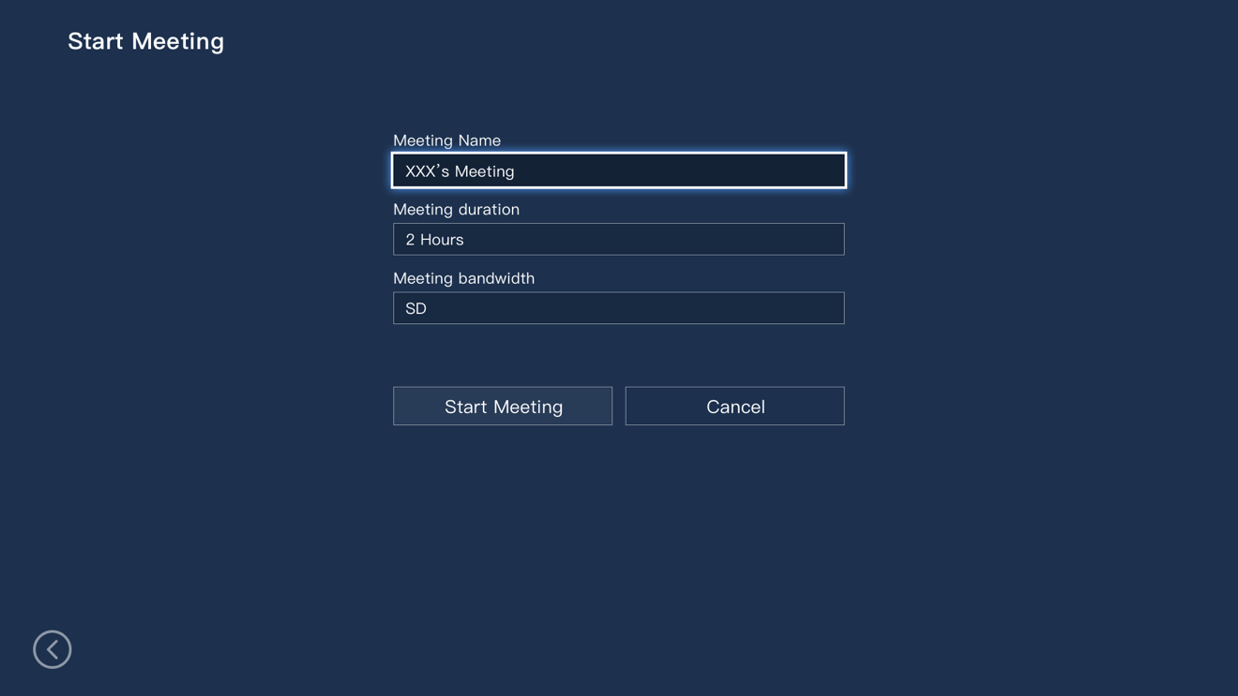
Step2: Set the meeting name, meeting duration, and meeting bandwidth.
Step3: Press the “Start Meeting” button and the system will show an invitation card, referring to Figure 5-4.
Figure 5-4 Invitation Card
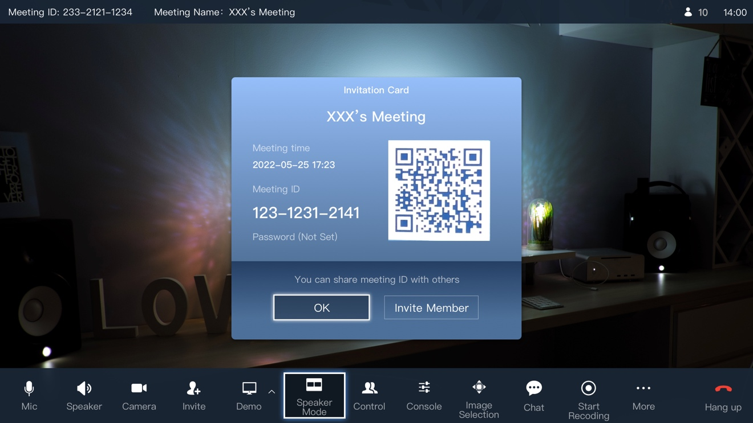
Step4: Press the “Invite Member” button to open the contact list. Select and invite contacts to join the meeting as either meeting members or visitors.
Step5: Enter the main page of the meeting.

Join Meeting
When a meeting is in progress, you can join it using the meeting ID and password as either a member or a visitor specified by the host.
Notes
- The permission of “Join by Meeting ID” is turned on in the settings by default but can be turned off by the host. If the permission is turned off, no one can join by the meeting ID without the invitation.
- The host can set the identity after joining by meeting in the settings, which includes the member and visitor. The member is the default option, meaning the identity will be a member after joining by the meeting ID.
Step1: Select “Join Meeting” on the meeting center page.
The system will show the “Join meeting” page, referring to Figure 5-5.
Figure 5-5 Join Meeting
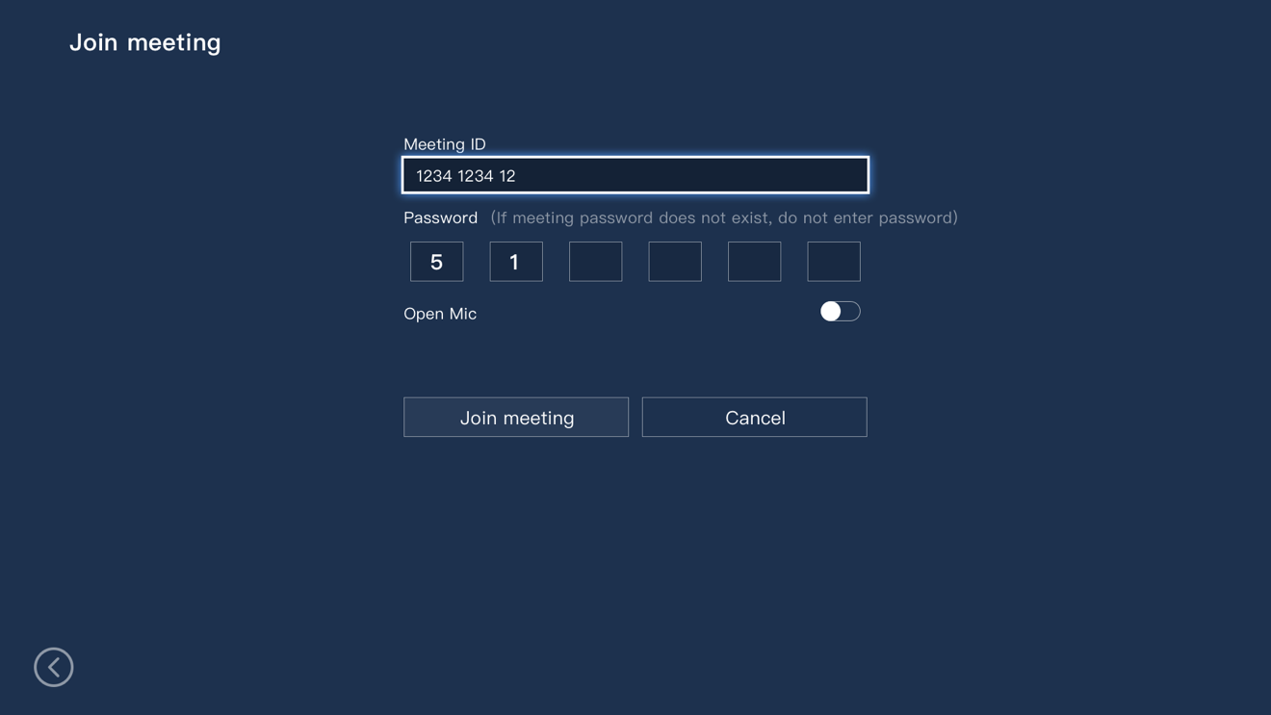
Step2: Enter the meeting ID and password.
Notes
The meeting password is optional. There is no need to enter if the meeting has no password.
Step3: Toggle the “Open Mic” button, which is turned off by default.
Step4: Press the “Join Meeting” button to enter the main page of the meeting.

Reserve Meeting
You can reserve a meeting before the commencement.
Step1: Select “Reserve Meeting” on the meeting center page.
The system will show the reserve meeting page, referring to Figure 5-6.
Figure 5-6 Reserve Meeting
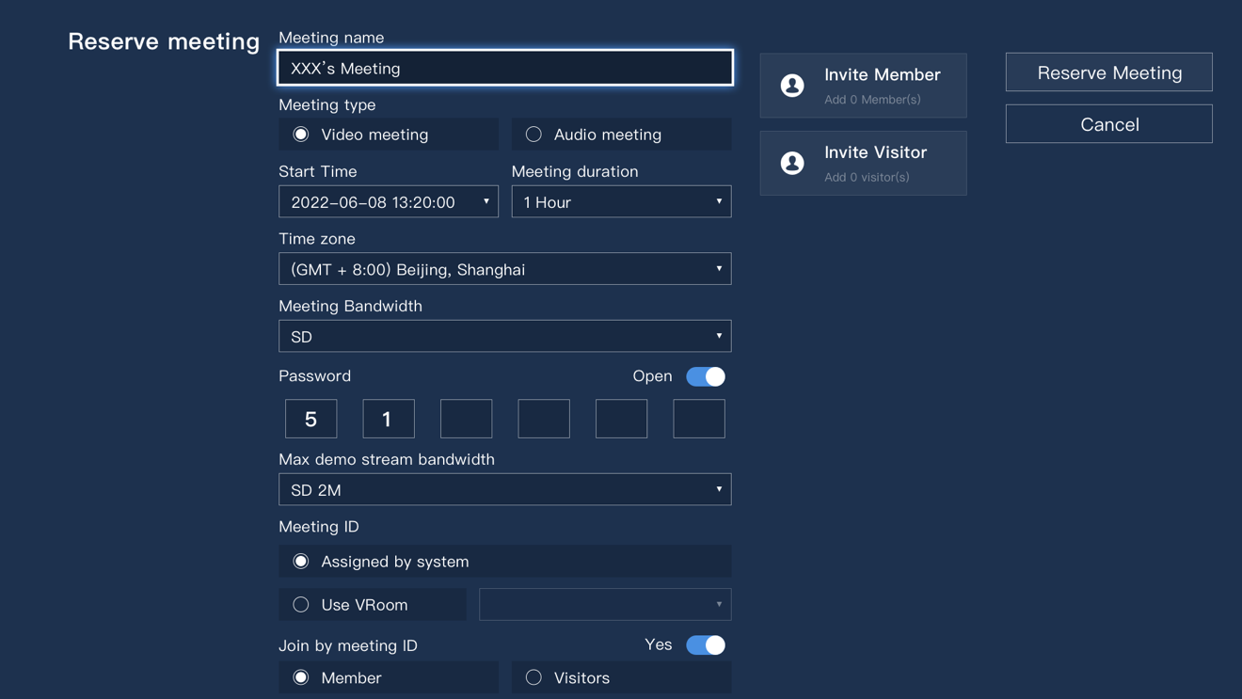
Step2: Set meeting parameters as illustrated in Table 5-1.
Table 5-1 Reserve Meeting Description
Parameter | Description
Meeting name | The name of the meeting; “XXX’s Meeting” by default
Meeting type | The type of the meeting  - Video meeting  Both video and audio are allowed in the meeting.  - Audio meeting  Only audio is allowed in the meeting.
Start time | The start time of the meeting; Current time by default
Meeting duration | The duration of the meeting; Two hours by default
Time zone | The time zone of the meeting
Meeting bandwidth | The resolution of the meeting; SD by default
Password | The password is a switch, closed by default.  - Open (On): When the password is turned on, the host needs to set the password. Others without the invitation need to input the password to join the meeting.  - Close (Off): Others without the invitation can join the meeting without inputting the password.
Max demo stream bandwidth | Notes  The demo stream is the same as the sub stream, which is a secondary stream usually coming from the computer screen for presentation or sharing purposes at the conference.  This option sets the resolution of the sub stream, SD 2M by default.
Meeting ID | Set the meeting ID. The default option is “Assigned by system”.  - Assigned by System: The meeting ID is randomly assigned by the system.  - Use VRoom: Use a virtual meeting room to reserve a meeting.
Join by meeting ID | Allow people without the invitation to join using the meeting ID. The option is turned on by default.
Identity of joining by meeting ID | Set the identity when joining using the meeting ID. The default option is a member.  Notes  The permissions of a visitor are lower than a member. A visitor is forced to mute and turn off the camera when joining the meeting and can only view instead of interacting in the meeting. The visitor’s endpoint cannot show in the meeting view but can raise hands to talk.
Open mic | This option is a switch, closed by default. When it is closed, people will mute their microphone when joining the meeting.
Allow to join before the host | Allows people to join the meeting ahead of the host, allowed by default.  - Allow: People can join an existed meeting even if there is no host.  - Not allow: People can only join when there is a host.
When a participant is called, other participants handing up automatically lower their hands. | When a hands-up member is selected to talk in the meeting, other hands-up members will automatically lower their hands.
Allow a third-party terminal to actively join the meeting | A third-party terminal or an endpoint can join the meeting without the invitation.

Step3: Select “Invite Member” to invite meeting contacts as members.
The system will show the “Invite Member” panel, referring to Figure 5-7.
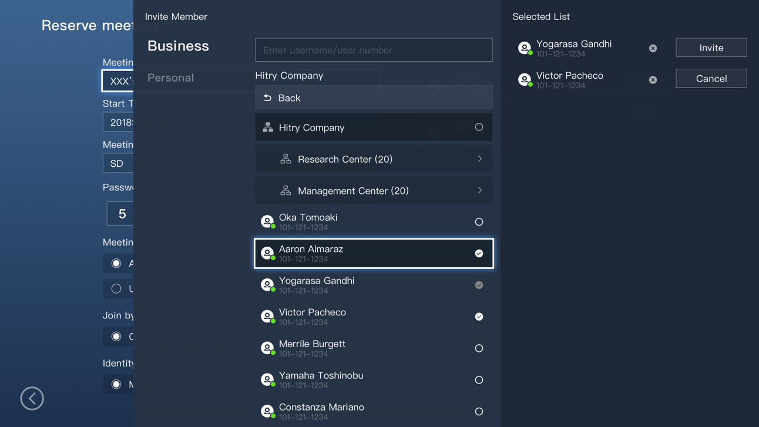
Step4: Select members from the contact list and press the “Invite” button.
Members will receive the invitation from the system, so they can join the meeting.
Step5: Select “Invite Visitor” to invite meeting contacts as visitors.
Step6: Select “Reserve Meeting” to reserve the meeting which will show in the meeting list.

Meeting Controls
The video conferencing endpoint can be a host or a non-host in a meeting. Specifically, the non-host endpoint can be a member or a visitor.
- Host Endpoint: The host endpoint can control all non-host endpoints. The endpoint which creates the meeting is the host endpoint by default.
- Non-host Endpoint: The non-host endpoint can be a member or a visitor endpoint. A visitor endpoint can only watch the meeting and will not be shown in the meeting view.

Host Endpoint
When the endpoint is served as a host, the meeting page will show the main menu, referring to Figure 5-8, after the button is pressed.
Figure 5-8 Host’s Meeting View
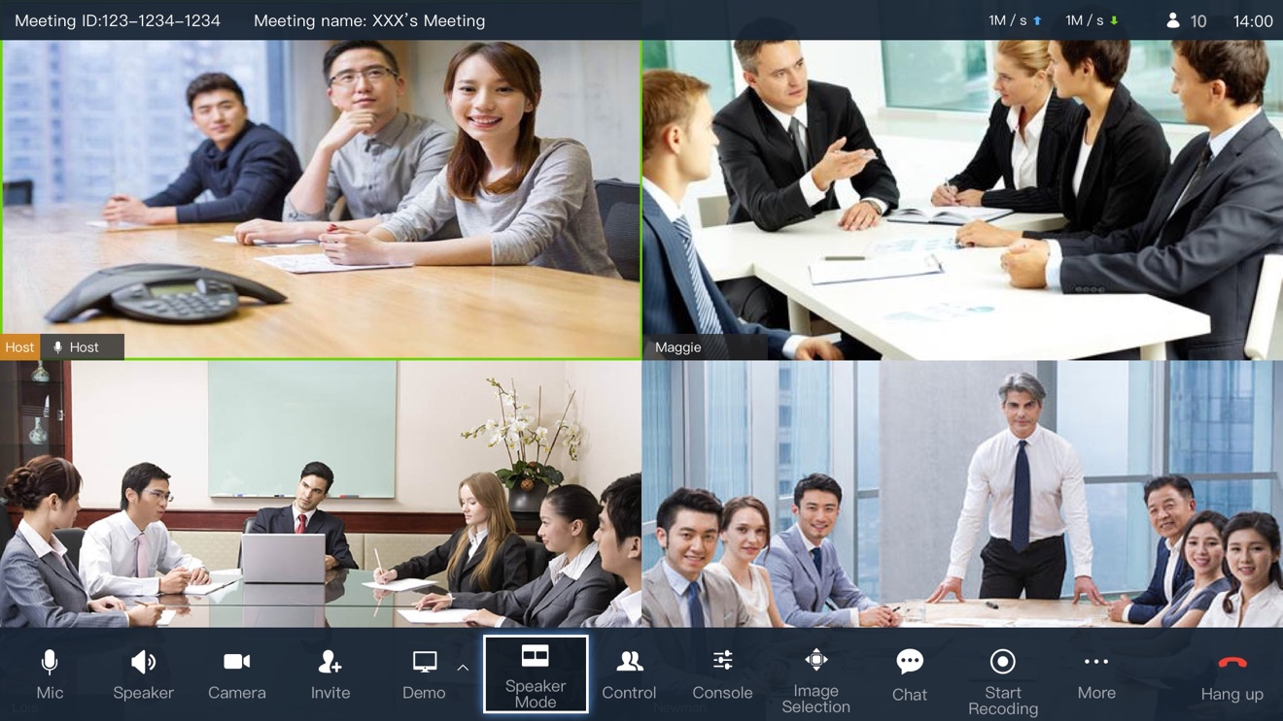
The controlling details of a host endpoint are described in Table 5-2.
Table 5-2 Controlling Details of Host Endpoint
Parameter | Description
Mic | Turn on/off the microphone.
Speaker | Turn on/off the speaker.
Camera | Turn on/off the camera.
Invite | Open the contact list to invite members or visitors.
Demo | Connect the endpoint to a computer to share content.  - Demo Image: Share videos or images from the computer.  - Whiteboard: Share an interactive whiteboard.  NOTES  Visitors do not have the demo button and are unable to send the demo stream for sharing purposes.
Display Mode | Display the layout of the meeting view. Speaker mode is the default layout but can also convert to the pic-in-pic or split-screen mode.
Control | Display the member list to control all or each member or visitor.
Console | Adjust the local audio volume.
Start Recording | Start recording the meeting.
Image Selection | Select different endpoints. Zoom in or out a single endpoint.
Chat | Chat with members and visitors. The host can change the chat modes.
More | Start Broadcast Tour: Start a tour for all endpoints.  NOTES  Set the tour configuration on the cloud meeting management platform.
Start Specified Tour: Start a tour for specified endpoints.
NOTES
Set the tour configuration on the cloud meeting management platform.
 | Extend Meeting: Extend the meeting time.
Settings: The host can control the meeting in the setting panel.
- Open Mic: Turn on/off the microphone. Turn off by default.
- Allow turn on Mic by terminal: The endpoint can turn on the local microphone when it is closed by the host.
- Join by meeting ID: Allow endpoints without the invitation to join by the meeting ID. This option is turned on by default.
- Identity after joining by meeting ID: Set the identity of the endpoint after joining the meeting. The identity can be set to the member which is the default option and the visitor.
- Share [demo stream] permission: Set the permission for sending the demo stream. The default option is for all participants but can be set to the host only.
- Lock Demo: This is turned on by default. If it is turned on, others cannot send the demo stream while it is being sent by a member.
- When a participant is called, other participants handing up automatically hand down: This is turned on by default. If it is turned on, other hands-up members and visitors will lower their hands when a selected one is talking.
- Enable exit and join prompts: This is turned on by default. When it is turned on, there will be prompts for members joining and leaving the meeting.
Hang up | The host endpoint can leave or end the meeting.

Non-host Endpoint
A non-host endpoint refers to the endpoint used for a member or a visitor when joining a meeting. In particular, a member’s meeting view is displayed in Figure 5-9.
Notes
- The visitor endpoint is intended to watch the meeting by default. It can raise hands to talk but is unable to send the demo stream to share content.
- The visitor endpoint is forced to turn off the microphone and camera when joining the meeting.
- The meeting view and list cannot display the visitor endpoint by default. When the visitor is being selected to talk, it will display in the meeting view and list.

Figure 5-9 Member’s Meeting View
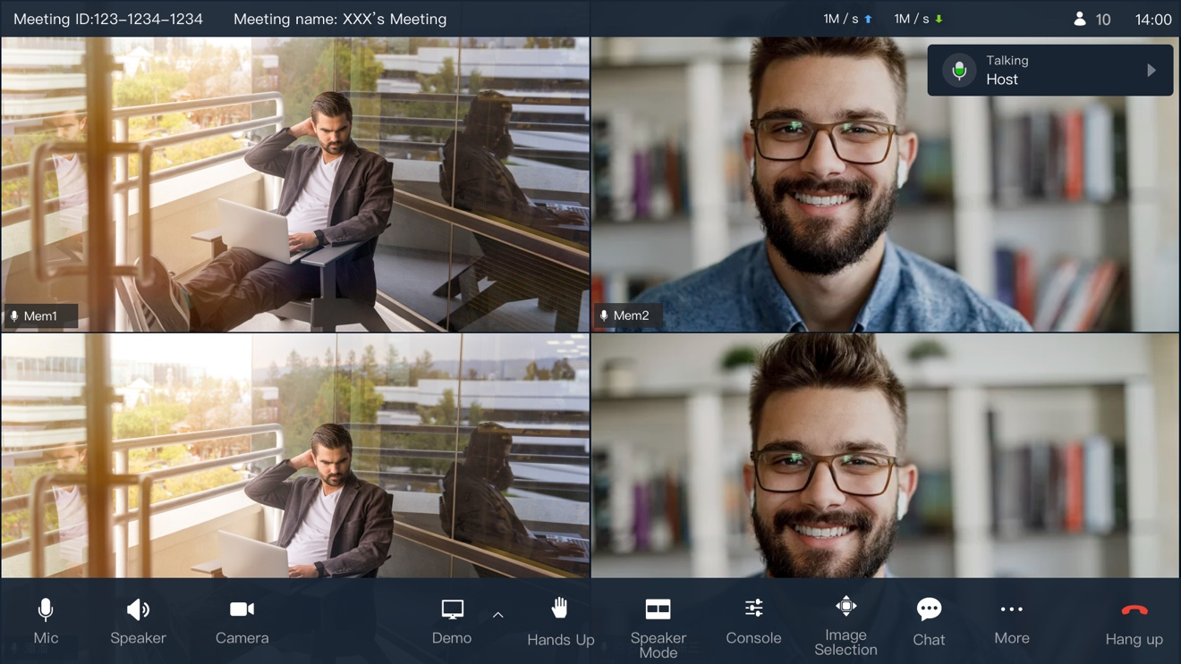
The controlling details of a non-host endpoint are described in Table 5-3.
Table 5-3 Controlling Details of Non-host Endpoint
Parameter | Description
Mic | Turn on/off the microphone.
Speaker | Turn on/off the speaker.
Camera | Turn on/off the camera.
Demo | Connect the endpoint to a computer to share content.  - Demo Image: Share videos or images from the computer.  - Whiteboard: Share an interactive whiteboard.  NOTES  Visitors do not have the demo button and are unable to send the demo stream for sharing purposes.
Hands up | Raise hands to notify the host of talking.
Display Mode | Display the layout of the meeting view. Speaker mode is the default layout but can also convert to the pic-in-pic or split-screen mode.
Console | Adjust the local audio volume.
Image Selection | Select different endpoints. Zoom in or out a single endpoint.
Chat | Chat with members and visitors.
More | Switch to audio meeting: Switch the local endpoint to the audio meeting.
Hang up | Leave the meeting.

System Settings

Press the “Setting” Button to enter the system setting page, referring to Figure 6-1.
Figure 6-1 System Settings
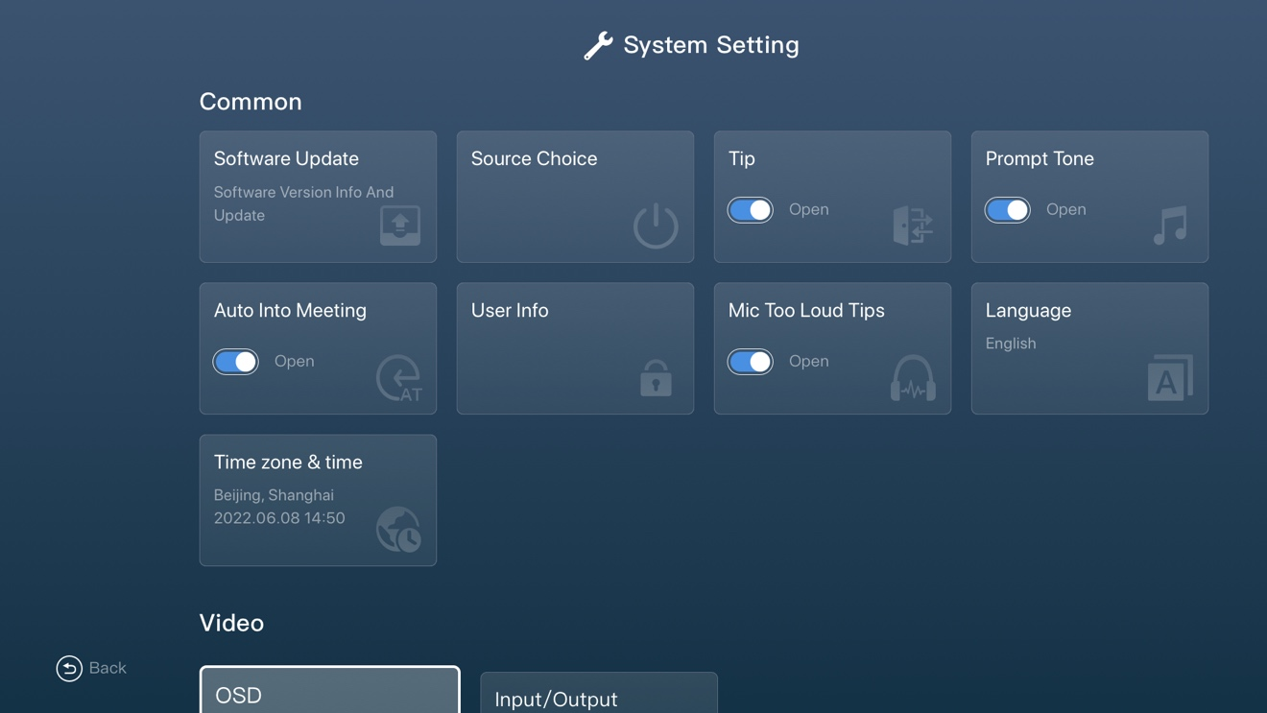

Common Settings
Common settings are displayed in Figure 6-2.
Figure 6-2 Common Settings
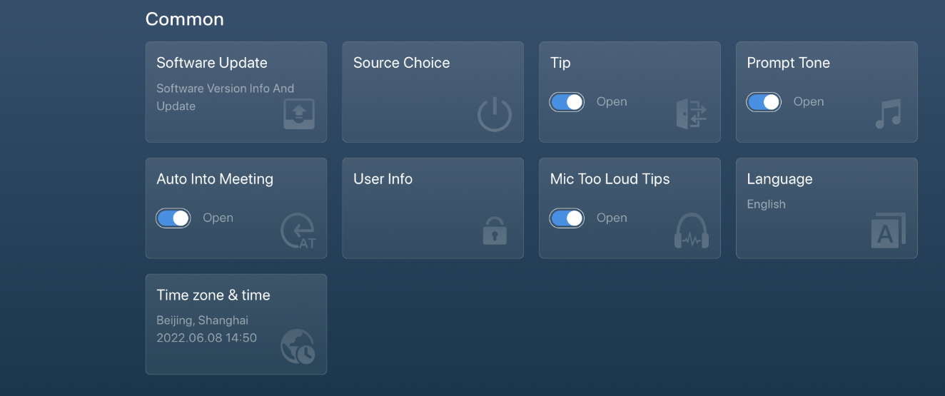
Common settings are described in Table 6-1.

Table 6-1 Common Settings
Parameter | Description
Software Update | - Check the current endpoint, system, and application version.  - Check and update the system.
Source Choice | - Set standby time.  - Set power options including shutdown, standby, restart and cancel.
Tip | Turn on/off the text prompts when someone is joining or leaving the meeting.
Prompt Tone | Turn on/off the audio prompts when someone is joining or leaving the meeting.
Auto Into Meeting | Turn on/off the automatic conference joining function of the endpoint. It is turned off by default. The endpoint needs to be manually selected to enter the meeting.
User Info | Set the account information
Mic Too Loud Tips | Turn on/off the prompts when the microphone is too loud. It is turned on by default.
Language | Set the system language.
Time Zone & Time | Set the time zone and local time.

Video Settings
Video Settings are displayed in Figure 6-3.
Figure 6-3 Video Settings
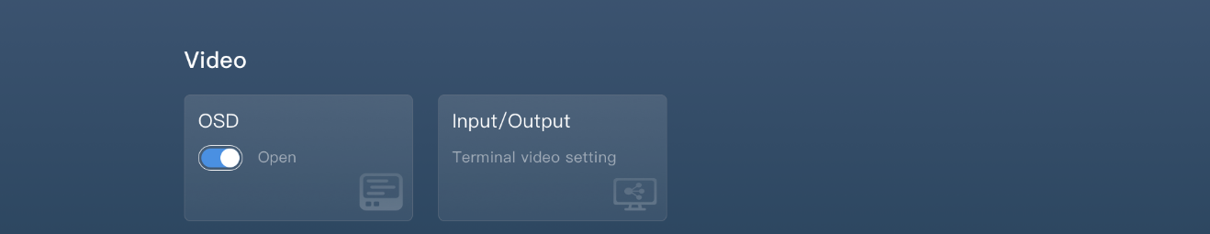
Video Settings are described in Table 6-2.
Table 6-2 Video Settings
Parameter | Description
OSD | Turn on/off the OSD display in the meeting.
Input/Output | Change the inputs and outputs of the endpoint.

Audio Settings
Audio Settings are displayed in Figure 6-4.
Figure 6-4 Audio Settings
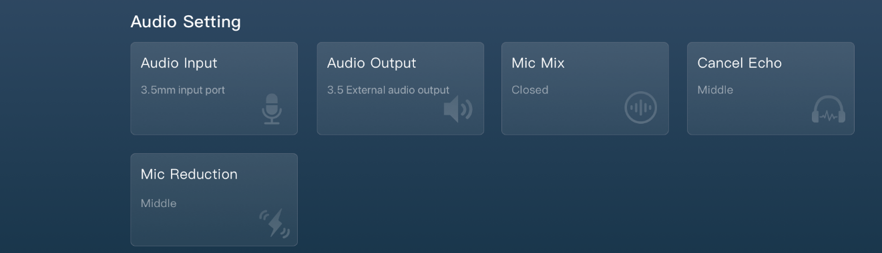
Audio Settings are described in Table 6-3.
Table 6-3 Audio Settings
Parameter | Description
Audio Input | Select audio inputs: RCA connector, 6.5mm connector, Cannon input.
Audio Output | Sound output or TV output.
Mic Mix | Mix the mainstream audio with the sub-stream audio.
Cancel Echo | This is the echo cancellation function.
Mic Reduction | This is the noise reduction function of the microphone.

Network Settings
Network Settings are displayed in Figure 6-5.
Figure 6-5 Network Settings
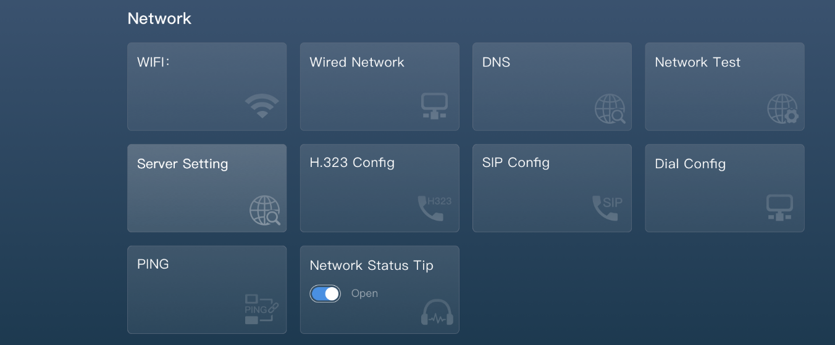
Network Settings are described in Table 6-4.
Table 6-4 Network Settings
Parameter | Description
WIFI | Set the WIFI of the endpoint.
Wired Network | Set the wired network configurations.
DNS | Set the domain name system.
Network Test | Test the network including the uplink, downlink, delay, jitter, and packet loss rate.
Server Setting | Set the server.
H.323 Config | Configure the H323 devices.
SIP Config | Configure the SIP devices.
Dial Config | Set the dial bandwidth and preference.
PING | PING the IP address to see if it works.
Network Status Tip | Show tips on the network status.

Other Settings
Other Settings are displayed in Figure 6-6.
Figure 6-6 Other Settings
Other Settings are described in Table 6-5.
Table 6-5 Other Settings
Parameter | Description
Default Setting | Restore to the default setting.
Security | Increase the H.323, SIP and Web security.

Appendix1 Technical Specification

Parameter | Description
Endpoint Size | 435mm×280mm×66mm
Packaging Size | 573mm × 407mm × 173mm（Reference Size，±5mm）
Net Weight | 4.5kg
Gross Weight | 6kg
Working Voltage | AC 100V-240V  50Hz～60Hz
Max Power | 60W
Temperature | 0℃～+45℃ (Working Status)  -40℃～+70℃ (Non-working Status)
Relative Humidity | 10%～80% (Working Status)  0%～95% (Non-working Status)
Ambient Noise | ＜46dBA SPL

