Conference TV System Multipoint Control Unit
DH-VCS-MCU95F0-4K
Quick Start Guide

ZHEJIANG DAHUA VISION TECHNOLOGY CO., LTD.

ZHEJIANG DAHUA VISION TECHNOLOGY CO., LTD.
V1.0.0

V1.0.0

Foreword

General
This document details how to quickly configure DH-VCS-MCU95XX series.
Applicable models: DH-VCS-MCU95F0-4K
Safety Instructions
The following symbols may appear in this document and their meanings are as follows:
Symbol | Description
DANGER | Indicates a high potential hazard which, if not avoided, will result in death or serious injury.
WARNING | Indicates a medium or low potential hazard which, if not avoided, could result in slight or moderate injury.
CAUTION | Indicates a potential risk which, if not avoided, could result in property damage, data loss, lower performance, or unpredictable result.
 | Indicates ESD devices.
 | Indicates the danger of high voltage.
 | Indicates strong laser radiation.
TIPS | Provides methods to help you solve a problem or save you time.
NOTE | Provides additional information as the emphasis and supplement to the text.

Important Safety Instructions

The following section describes how to use this product correctly and how to prevent dangers and property loss in using it. Before using this product, read this Manual carefully and comply with it strictly. Keep this Manual properly after reading.
WARNING
- Use the battery exactly as prescribed; otherwise, the battery might catch fire or explode!
- Always replace with the same type of batteries!
- Use the wires (power cables) recommended for the region where the device is used within the specified range of specifications.
- Always use standard power adapters for the device. Otherwise you will be solely liable for possible personal injuries or device damages.
- Connect products of Type I structure to the outlet sockets in power grid with grounding connections.
- The appliance coupler is a disconnection device. Keep a convenient angle when using it.
CAUTION
- To prevent the password from being stolen, change the default password immediately after the device is deployed.
- Do not place or install the device near a heat source or where there is direct sunshine.
- Do not install the device in a humid, dusty, or smoggy place.
- Keep the device installed horizontally or install it on a stable place to prevent it from falling.
- Do not drop or splash liquid onto the device, and make sure that there is no object filled with liquid on the device to prevent liquid from flowing into the device.
- Install the device in a well-ventilated place, and do not block the ventilation opening.
- Use the device only within the rated input and output range.
- Do not dismantle the device without permission.
- Transport, use and store the Device under the allowed humidity and temperature conditions.
Disclaimer
- The instruction is for reference only, and the actual product shall prevail.
- The instruction and program are subject to change without notice.
- We are not liable for any loss caused by the operations that do not comply with the instruction.
- There still might be deviation in technical data, functions and operation descriptions, or errors in print. If there is any doubt or dispute, please refer to our final explanation.
- All other company names and trademarks mentioned herein are the properties of their respective owners.

Table of Contents

Foreword II
Important Safety Instructions III
1 Product Introduction 1
1.1 Overview 1
1.2 Interface description 1
1.2.1 Front Panel 1
1.2.2 Rear Panel 2
2 Networking graph 3
3 System Operations 4
3.1 Logging in System 4
3.2 Adding Devices 5
3.3 Creating a Conference 6
3.4 Controlling Conferences 11
4 Network Configuration 1
Appendix 1 Port Mapping Table 2

Product Introduction

Overview
Models | Introduction | Hardware Architecture
DH-VCS-MCU95F0-4K | The MCU95F0-4K is a competitive product of the new-generation universal transcoding MCUs. It is wholly designed in carrier-class standard ATCA architecture and features high performance, high density, high reliability, long lifespan, and smooth scalability. It supports concurrent access from a maximum of 80 routes of 1080P@30FPS and applies to the system networking of medium-sized conferences. It allows the connection to various intelligent terminals to supply users with excellent video conference experience. | 3 U rack, supporting a maximum of two hot-swappable service boards  1+1 redundancy power supplies

Interface description

Front Panel
              - Front panel of the DH-VCS-MCU95F0-4K
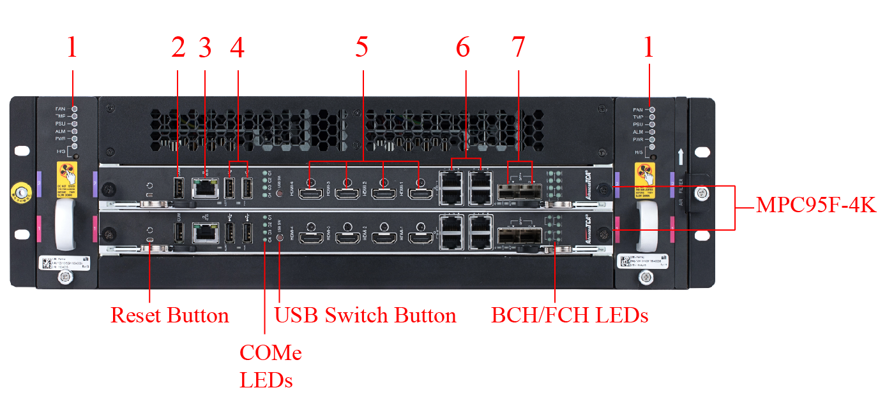
                - Front panel description of the DH-VCS-MCU95F0-4K
No. | Name | Description
1 | Device indicator | - FAN: fan indicator. Off for normal and steady in red for abnormal.  - TMP: temperature indicator. Off for normal and steady in red for abnormal.  - PSU: power supply monitoring indicator. Off for normal and steady in red for abnormal.  - ALM: alarm indicator. Steady in green for normal and steady in red for abnormal.  - PWR: power indicator.
2 | Serial Console port | Users can access the serial ports of four COMe modules simultaneously via this port by using a USB Type-A to USB Type-A cable.
3 | Management Ethernet Port | To access the control plane interfaces of the four COMe modules simultaneously via Ethernet.
4 | USB Port | There are two USB 2.0 ports on the front panel, which are shared by four COMe Modules onthe board.
5 | HDMI | HDMI-1, HDMI-2, HDMI-3, HDMI-4 corresponding to COMe-1,COMe-2, COMe-3, COMe-4 respectively.
6 | Network port | Connects to a network.  - Default IP address: 192.168.1.108. You only need to use any one of the four network ports on the primary service card.  - Four network ports are bound (to bond0) by default.
7 | SFP+ | Optional.

Rear Panel
WARNING
This device provides two power sockets. To disconnect power supply from the device, you need to disconnect connections to the two sockets.
              - Rear panel of the DH-VCS-MCU95F0-4K
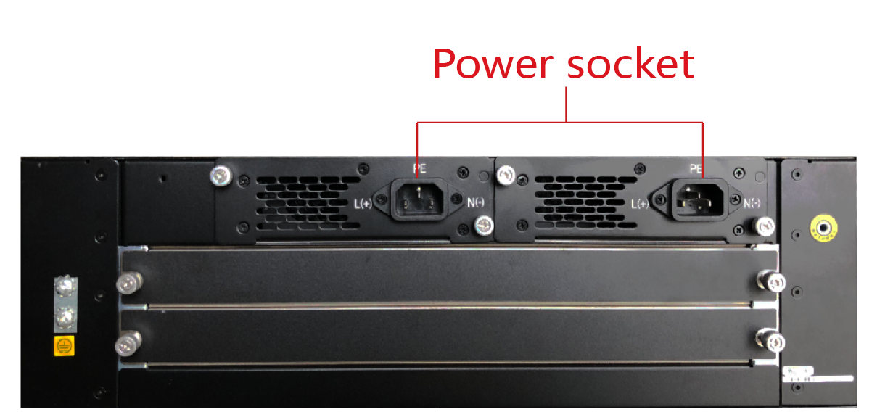

Networking graph

Figure 2-1 shows the networking graph of DH-VCS-MCU95F0-4K.
              - Networking graph
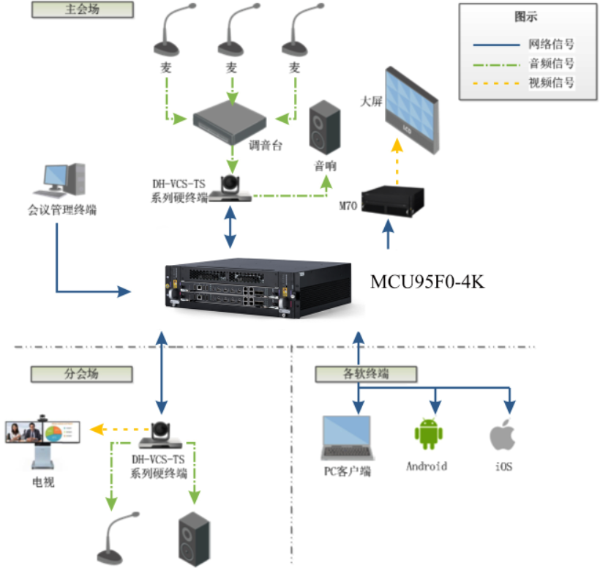

System Operations

Logging in System
CAUTION
- Use Chrome 44 (including) and earlier versions or the high-speed mode of all sorts of Chinese browsers (such as the 360 browser, Sogou browser, and QQ browser) that are based on the Chrome framework.
- If it is the first time for you to use this system, you can follow the startup wizard to get familiar with the usage process quickly.
- In the browser address bar, enter the factory IP address of the video conference management system, and then press Enter.
The Login interface is displayed. See Figure 3-1.
              - login interface
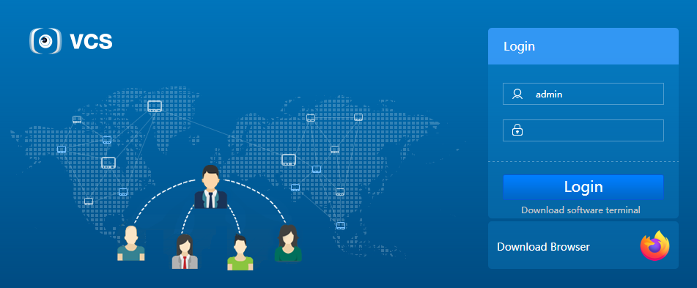
- Enter the user name and password.
The default user name is admin and the default password is admin123.
- Click Log In.
- When you log in to the system for the first time, the Startup Wizard interface is displayed. you can follow the startup wizard to get familiar with the usage process quickly.
- If you do not log in to the system for the first time, the main interface is displayed directly.
NOTE
        - If the password is already changed in the startup wizard, use the new password for login.
        - You can select System Configuration > User Management, select the user whose password needs to be changed, and then click to change the password.

Adding Devices
- On the main interface of the video conference management system, select Device Management > Manage Devices > All Devices.
The Security questions interface is displayed. See Figure 3-2.
              - All Devices
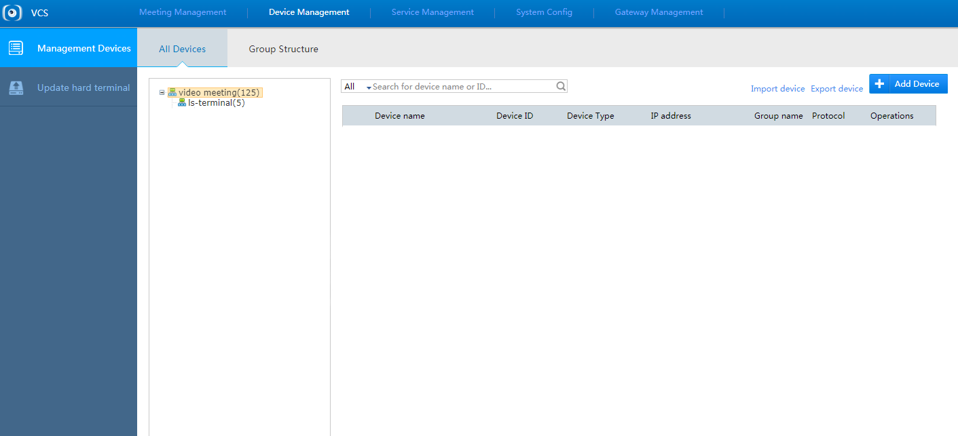
- Click .
The Add Device interface is displayed. See Figure 3-3.
              - Add Device
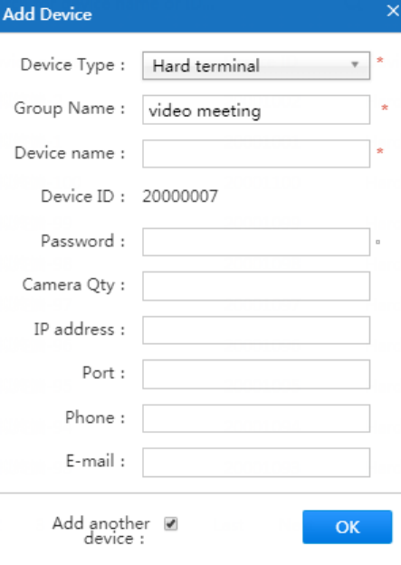
- Set parameters. For details about the parameter description, see Table 3-1.
                - Parameter description about adding devices
Parameter | Description
Device type | Device types are classified into hard terminals, soft terminals, RTSP terminals, Dahua devices, and H323 and STDSIP (standard SIP) devices.
Organization name | Name of the organization where the device is located.
Device name | Customized.
Device ID | The device ID is generated automatically and applies to:  - Hard terminal: device ID registered with the system  - Soft terminal: user name used for logging in to the PC or mobile conference terminal
Authentication password | Password for logging in to the hard terminal, soft terminal, PC, and mobile conference terminal.  When the authentication password is null (not set), the system sets a default password 123456 automatically.
Number of cameras | Name of cameras. The default value 1 indicates an integrated terminal.
IP address | IP address of the device. The terminal with this IP address can create and join a conference by default.
Port | Port of the device.
Telephone | Telephone number of the device contact.
E-mail | Email address of the device contact.
Add device | - Select it: Add more devices.  - Do not select it: Stop adding devices.
- Click .
Device addition is finished.

Creating a Conference
You can create a fusion conference and forward a conference. The following uses creating a fusion conference as an example to describe the detailed operation procedure.
- On the main interface of the system, select Conference Management and click to create a conference.
The Create Conference interface is displayed. See Figure 3-4.
              - Conference creation
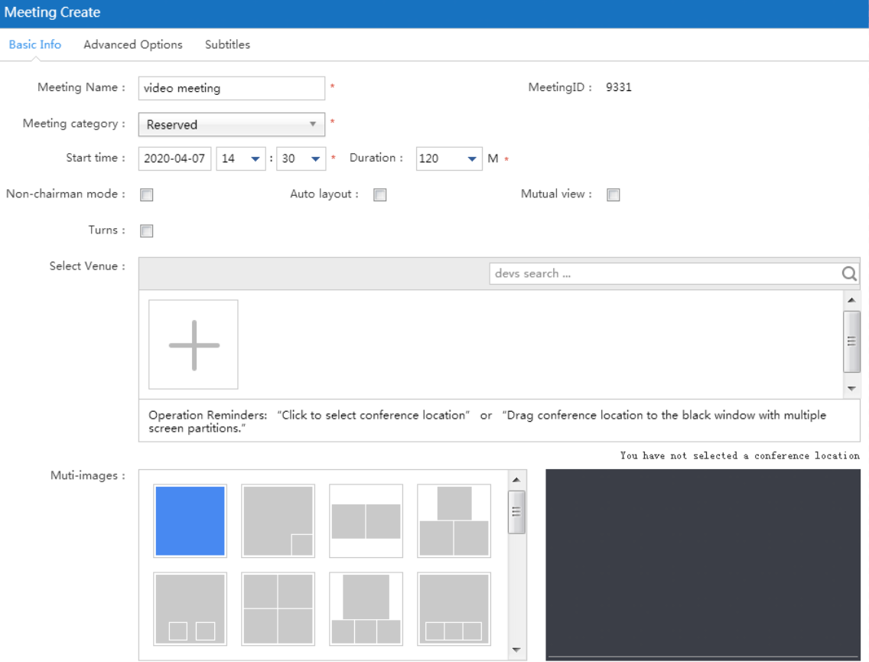
- Click the Basic Information tab and set basic information about the conference. For parameter description, see Table 3-2.
                - Parameter description about basic information
Description | Parameter
Conference name | Name of the conference. Customized.
Conference type | The value options are Instant conference and Schedule conference.  - Instant conference: The conference starts immediately after you set the conference name, duration, and venue.  - Schedule conference: Schedule the conference time based on the required time.
Start time | Start time of the conference. When Conference type is set to Schedule conference, you need to set the start time.
Duration | Duration of the conference.
Non-chair mode | If you select this check box, the conference will be created in non-chair mode, which means that no chair can be allocated on the venue.
Automatic layout | If you select this check box, automatic layout is enabled, in which multi-picture setting in the following will become unavailable.
Mutual watch | If you select this check box, the mutual watch mode is enabled. This mode is applicable only to a two-party conference.
Tour | If you select this check box, tour among venues is enabled. It is not selected by default.
Fix large image | If you select this check box after tour is enabled, tour is performed among fixed large images.
Tour time | After tour is enabled, you can set Tour time, which indicates the time how long each venue image keeps. After the time expires, the image is switched to the next venue automatically.
Select venue | Select the device to be used in the conference.  - Enter the conference name in the text box and then click to add the venue.  - Click . In the displayed Add Device dialog box, select the device and click OK to add the venue.  - If you do not select Non-chair mode, you can set a venue to the main venue by clicking 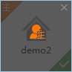 at the venue center. To cancel the main venue setting, click it again.
Multi-picture | You can select a multi-picture preview layout as required.
- Click the Advanced Options tab.
The Advanced Options interface is displayed. See Figure 3-5.
              - Advanced Options
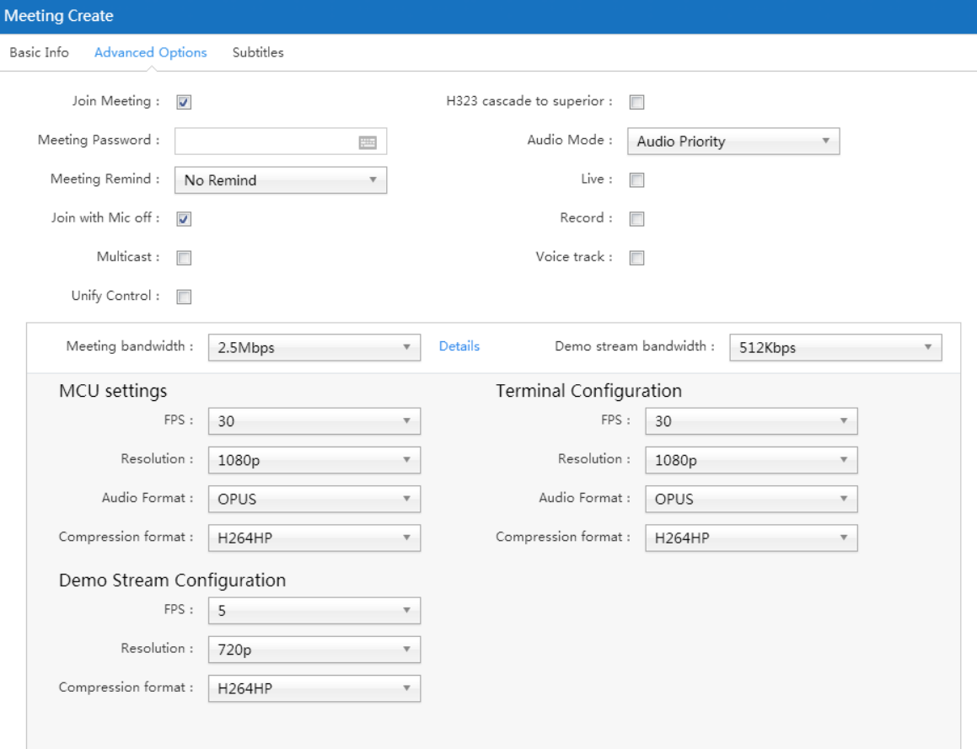
- Set parameters about advanced options. For parameter description, see Table 3-3.
                - Parameter description about advanced options
Description | Parameter
Join actively | If you select this check box, the function of joining a conference actively is enabled.  - If this function is enabled, unselected venues can be added to the conference using the conference ID and conference password.  - If this function is disabled, only selected venues can be added to the conference.
Conference password | Password of the conference. It is required by the venues to be added to the conference.
Conference notification | Select an option No notification or Email notification from the drop-down list.  Before selecting Email notification, select System Configuration > Configuration > Network Service Configuration and configure the email server.
Fusion | If you select this check box, the fusion function is enabled. In this case, MCU configuration in the following is available. Fusing the videos from different terminals into one video over the MCU can save bandwidths.
Join with microphone off | If you select this check box, the attendee joins the conference with the microphone off automatically.
Multicast | If you select this check box, the multicast mode is enabled.
Centralized conference control | If you select this check box, the centralized conference control function is enabled.
H323 cascading to upper level | If you select this check box, this conference is used as a terminal to cascade to the upper level over H323.
Audio mode | Select an option Audio preferred or Mouth and voice synchronized from the drop-down list.
Live broadcast | If you select this check box, live broadcast is enabled, so that you can live broadcast the conference in the recording and broadcasting system.
Recording and broadcasting | If you select this check box, recording and broadcasting is enabled, so that you can record and broadcast the conference in the recording and broadcasting system.
Voice motivation | If you select this check box, the voice motivation function is enabled.  - If a large image is set in the conference layout, the venue with the loudest attendee volume is displayed in the image.  - If no large image is set in the conference layout, the venue with the loudest attendee volume is displayed in the first image.
Join with microphone off | If you select this check box, the attendee join the conference with the microphone off automatically.
Conference bandwidth | Select a conference bandwidth based on actual conditions. The conference bandwidth is composed of the video bandwidth, audio bandwidth, and presentation stream bandwidth.
Presentation stream bandwidth | Select a presentation stream bandwidth based on actual conditions.
MCU configuration | Only a fusion conference is supported. Set the FPS, resolution, audio format, and code format of the fused image.  - FPS: The frame rate of the fusion stream should be consistent with the setting on the terminal. 30 is selected by default.  - Resolution: The options are CIF, 4CIF, 720p, 1080p, and 4K. 1080p is selected by default.  - Audio format: The options are OPUS, G.711, G.722.1, G.719, G.722, G.722.1.AnnexC, G.728, G729, AAC LC, and MP3. OPUS is selected by default.  - Code format: The options are H.263, H.263+, H.264 BP, H.264 HP, and H.265. H264HP is selected by default.
Terminal configuration | Set parameters about the video images uploaded from terminals to the MCU.
Presentation stream configuration | Set parameters about the presentation stream images uploaded from terminals.
- Click the Subtitle tab.
The Subtitle interface is displayed. See Figure 3-6.
The Subtitle tab is available only for fused conferences.
              - Subtitle
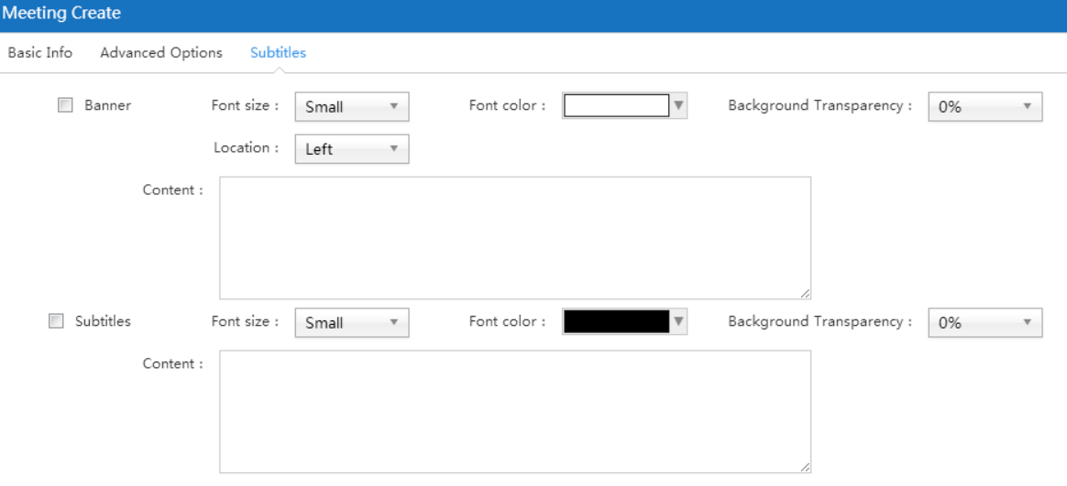
- Set Conference banner and Conference subtitle.
- The conference banner is displayed at the top of the screen. You can adjust the display position, font size, color, and background transparency as required.
- The conference subtitle is displayed in scrolling mode at the bottom of the screen. You can adjust the font size, text color, and background transparency as required.
- Click OK.
After a fused conference is created, you can select Conference Management > Current Conference to view it.

Controlling Conferences
You can control current conferences.
- Select Conference Management > Current Conference.
The Current Conference interface is displayed. See Figure 3-7.
              - Current Conference
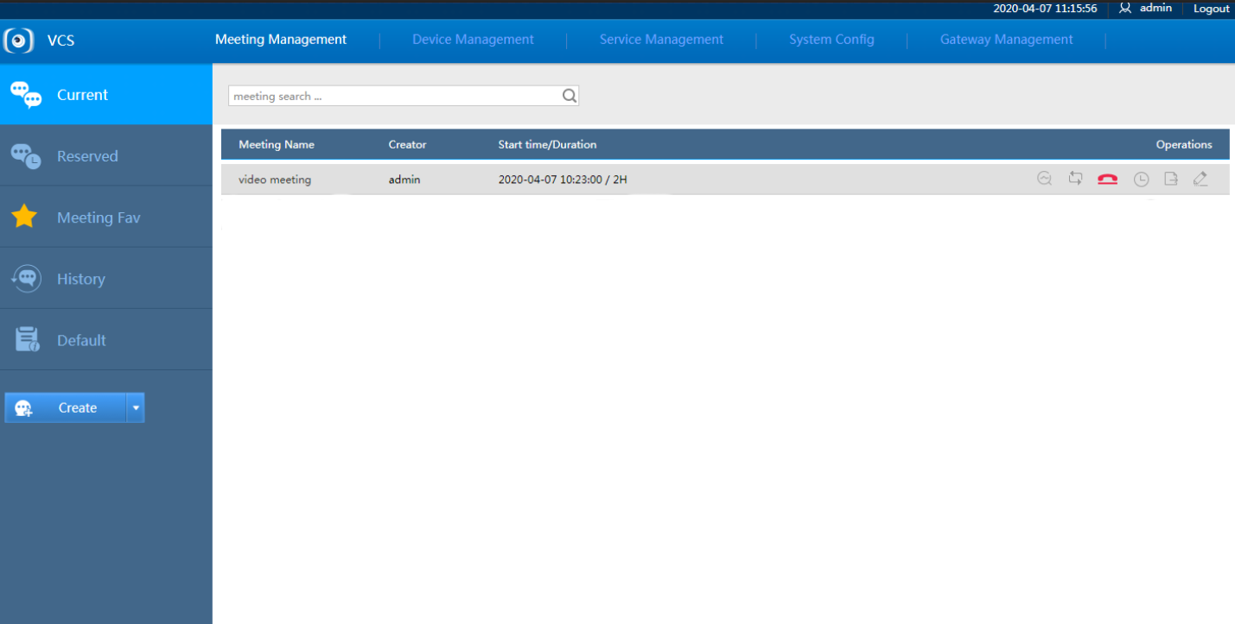
                - Parameter description about current conference
Icon | Description
 | Click this icon to view the venue network data.
Click this icon to set roll call tour. Take a roll call for all venues in tour mode based on the preset tour interval.
Only the chair has permission to use this function.
 | Click this icon to end the conference.
 | Click this icon to change the conference end time.
 | Click this icon to export conference information.
 | Click this icon to modify conference information.
- Click the selected conference and view details about the conference. See Figure 3-8.
              - Conference information
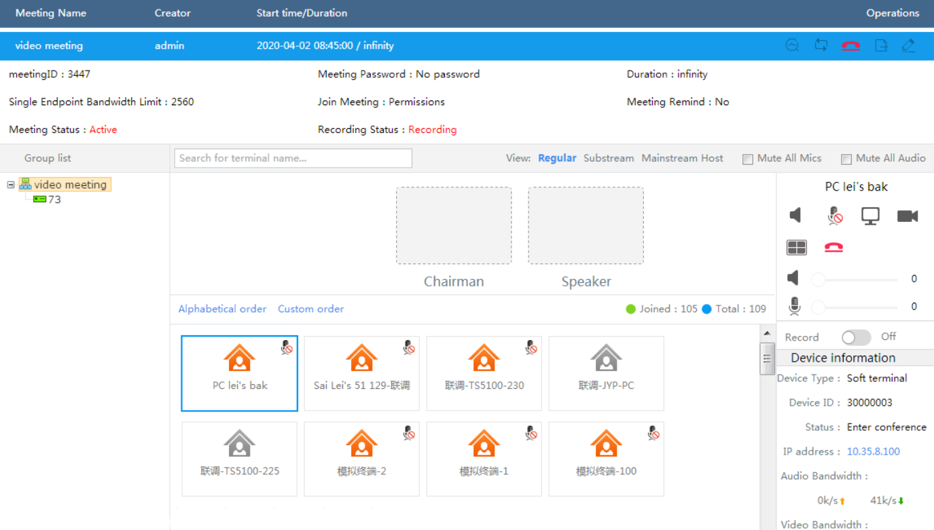
                - Parameter description about conference information
Icon | Description
 | Enter a terminal name to search for the terminal venue.
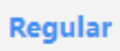 | Click this icon to display the default conference layout at all terminal venues.
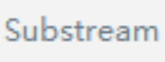 | Click this icon to display the presentation stream image at all terminal venues.
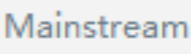 | Click this icon to display the fusion stream image at all terminal venues.
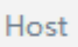 | Click this icon to display the chair image at all terminal venues and display the fusion stream image at the chair venue.
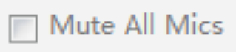 | Select this check box to disable the microphones of all members in the conference.
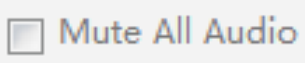 | Select this check box to mute all members in the conference.
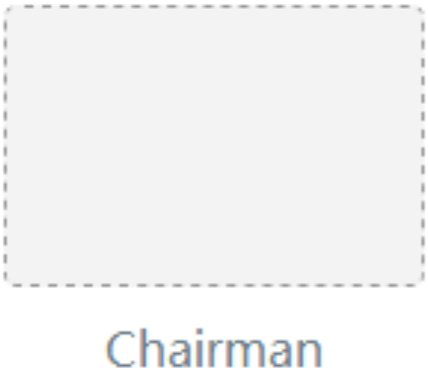 | Chairman seat indicates that the terminal at this place is the chair.  To cancel the terminal chair seat, click Remove.
Drag or double-click a terminal to this box to set a speaker.
To take the floor back from the terminal, click Remove.
 | Click this icon to control whether to mute the venue.
 | Click this icon to control whether to disable the microphone of the venue.
 | Click this icon to control whether to display the presentation.
 | Click this icon to preview the videos on this terminal and adjust the images, resolution, and total bandwidth of this terminal. You can select the venues to be adjusted from the conference list.
Click this icon to select the image fusion stream of this terminal and switch between the images of other attendees and the image layout displayed on this terminal.
- When selecting images, select a fusion stream based on actual network conditions and click OK to make the setting effective.
- When setting a layout, select a required layout and click OK to make the setting effective.
 | Click this icon to ask attendees to leave the conference.
 | Click this icon to invite the attendees out of the conference to the conference.
 | Drag the volume control bar to adjust the speaker volume of this terminal.
 | Drag the volume control bar to adjust the microphone volume of this terminal.
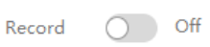 | Click this icon to control whether to enable recording and broadcasting.

Network Configuration

The factory IP address (for example, 192.168.1.108) of the MCU95F0-4K may be out of the IP address network segment that can be accessed. Therefore, you can log in to the video conference management system from a PC and modify the IP address of the MCU95F0-4K, so that the MCU95F0-4K can connect to the actual network, which facilitates future use and maintenance.
- Select System Management > Configuration > Network Configuration.
The Network Configuration interface is displayed. See Figure 4-1.
              - Network Configuration
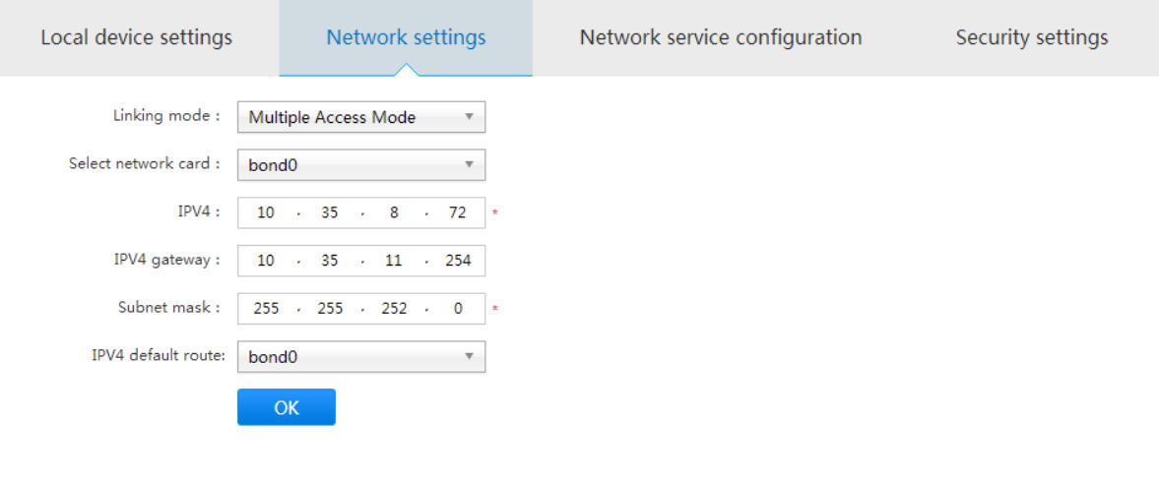
- Set parameters. For parameter description, see Table 4-1.
                - Parameter description for network configurations
Parameter | Description
Linking mode | The default value is Multiple access mode.
Select netword card | Select a required network adapter.
IPv4 | IP address of the MCU95F0-4K and the corresponding subnet mask and gateway.
IPv4 gateway
Subnet Mask
Default IPv4 route | Select a default route.
- Click .

- Port Mapping Table

Port Name | Port Type | Port Interval
SIP service port (configurable on the interface) | TCP | 50060 (changeable)
Web client (configurable on the interface) | TCP | 80 (modifiable)
Conference media port | UDP | 10000–20000 (changeable)
SSH management port (optional) | TCP | 22 (changeable)

